Title Page

Protocol Title**:** Efficacy and Safety of Novel GLP-1 Receptor Agonist KINE in Patients with Type 2 Diabetes Mellitus: A Randomized, Double-Blind, Placebo-Controlled Trial

Protocol Number: Click or tap here to enter text.

Amendment Number: Click or tap here to enter text.

Compound: KINE

Brief Title: Efficacy and Safety of KINE in Type 2 Diabetes: A Randomized, Double-Blind, Placebo-Controlled Study

Study Phase: Phase III

Sponsor Name: Click or tap here to enter text.

Legal Registered Address: Click or tap here to enter text.

Regulatory Agency Identifier Number(s): Click or tap here to enter text.

|  |  |
| --- | --- |
| **Registry** | **ID** |
|  |  |
|  |  |

[Pediatric Investigational Plan Number]

Click or tap here to enter text.

**Approval Date:**

Sponsor Signatory:

|  |  |  |
| --- | --- | --- |
| **[Name]**  **[Title]** |  | **Date** |

Medical Monitor Name and Contact Information [will be provided separately OR can be found in XX]

Protocol Amendment Summary of Changes Table

|  |  |
| --- | --- |
| DOCUMENT HISTORY | |
| Document | Date |
| [Amendment X] | [Day-Mon-Year] |
| [Amendment X] | [Day-Mon-Year] |
| [Amendment X] | [Day-Mon-Year] |
| Original Protocol | [Day-Mon-Year] |

Amendment [X] (Day-Month-Year)

Overall Rationale for the Amendment:

[INSERT rationale statement]

| Section # and Name | Description of Change | Brief Rationale |
| --- | --- | --- |
| [INSERT] | [INSERT] | [INSERT] |
| [INSERT] | [INSERT] | [INSERT] |
| [INSERT] | [INSERT] | [INSERT] |
|  |  |  |
|  |  |  |

Table of Contents

1. Protocol Summary 9

1.1. Synopsis 9

1.2. Schema 10

1.3. Schedule of Activities (SoA) 11

2. Introduction 12

2.1. Study Rationale 12

2.2. Background 12

2.3. Benefit/Risk Assessment 12

2.3.1. Risk Assessment 12

2.3.2. Benefit Assessment 12

2.3.3. Overall Benefit Risk Conclusion 12

3. Objectives, Endpoints, and Estimands 13

4. Study Design 14

4.1. Overall Design 14

4.2. Scientific Rationale for Study Design 14

4.2.1. Patient Input into Design 14

4.3. Justification for Dose 14

4.4. End-of-Study Definition 14

5. Study Population 15

5.1. Inclusion Criteria 15

5.2. Exclusion Criteria 24

5.3. Lifestyle Considerations 24

5.3.1. Meals and Dietary Restrictions 24

5.3.2. Caffeine, Alcohol, and Tobacco 25

5.3.3. Activity 25

5.3.4. Other Restrictions 25

5.4. Screen Failures 25

5.5. Criteria for Temporarily Delaying 25

6. Study Intervention(s) and Concomitant Therapy 26

6.1. Study Intervention(s) Administered 26

6.1.1. Medical Devices 27

6.2. Preparation, Handling, Storage, and Accountability 27

6.3. Assignment to Study Intervention 28

6.4. [Blinding, Masking] 28

6.5. Study Intervention Compliance 30

6.6. Dose Modification 30

6.6.1. Retreatment Criteria 30

6.7. Continued Access to Study Intervention after the End of the Study 30

6.8. Treatment of Overdose 30

6.9. Prior and Concomitant Therapy 30

7. Discontinuation of Study Intervention and Participant Discontinuation/Withdrawal 31

7.1. Discontinuation of Study Intervention 31

7.1.1. Liver Chemistry Stopping Criteria 31

7.1.2. QTc Stopping Criteria 36

7.1.3. Temporary Discontinuation 37

7.1.4. Rechallenge 37

7.2. Participant Discontinuation/Withdrawal from the Study 37

7.3. Lost to Follow up 37

8. Study Assessments and Procedures 38

8.1. Administrative [and General/Baseline] Procedures 38

8.2. [Efficacy and/or Immunogenicity] Assessments 38

8.3. Safety Assessments 39

8.3.1. Physical Examinations 39

8.3.2. Vital Signs 39

8.3.3. Electrocardiograms 39

8.3.4. Clinical Safety Laboratory Tests 39

8.3.5. Pregnancy Testing 39

8.3.6. Suicidal Ideation and Behavior Risk Monitoring 40

8.4. Adverse Events (AEs) Serious Adverse Events (SAEs), and Other Safety Reporting 41

8.4.1. Time Period and Frequency for Collecting AE and SAE Information 41

8.4.2. Method of Detecting AEs and SAEs 41

8.4.3. Follow-up of AEs and SAEs 41

8.4.4. Regulatory Reporting Requirements for SAEs 42

8.4.5. Pregnancy 42

8.4.6. Cardiovascular and Death Events 42

8.4.7. Disease-related Events and/or Disease-related Outcomes Not Qualifying as AEs or SAEs 42

8.4.8. Adverse Events of Special Interest 42

8.4.9. Medical Device Deficiencies 42

8.5. Pharmacokinetics 42

8.6. Pharmacodynamics 42

8.7. Genetics 42

8.8. Biomarkers 43

8.9. Immunogenicity Assessments 43

8.10. [Health Economics OR Medical Resource Utilization and Health Economics] 43

9. Statistical Considerations 44

9.1. Statistical [Hypothesis/Hypotheses] 44

9.1.1. Multiplicity Adjustment 44

9.2. Analysis Sets 44

9.3. Statistical Analyses 46

9.3.1. General Considerations 46

9.3.2. Primary [Endpoint(s)/Estimand(s)] Analysis 46

9.3.3. Secondary [Endpoint(s)/Estimand(s)] Analysis 46

9.3.4. [Tertiary/Exploratory/Other] [Endpoint(s)/Estimand(s)] Analysis 46

9.3.5. [Other] Safety Analyses 46

9.3.6. Other Analyses 46

9.4. Interim [Analysis/Analyses] 46

9.5. Sample Size Determination 47

10. Supporting Documentation and Operational Considerations 48

10.1. Appendix 1: Regulatory, Ethical, and Study Oversight Considerations 48

10.1.1. Regulatory and Ethical Considerations 48

10.1.2. Financial Disclosure 48

10.1.3. Informed Consent Process 49

10.1.4. Recruitment Strategy 49

10.1.5. Data Protection 49

10.1.6. Committees Structure 49

10.1.7. Dissemination of Clinical Study Data 49

10.1.8. Data Quality Assurance 49

10.1.9. Source Documents 50

10.1.10. Study and Site Start and Closure 51

10.1.11. Publication Policy 51

10.2. Appendix 2: Clinical Laboratory Tests 53

10.3. Appendix 3: AEs and SAEs: Definitions and Procedures for Recording, Evaluating, Follow-up, and Reporting 55

10.3.1. Definition of AE 55

10.3.2. Definition of SAE 56

10.3.3. Recording and Follow-Up of AE and/or SAE 57

10.3.4. Reporting of SAEs 59

10.4. Appendix 4: Contraceptive and Barrier Guidance 60

10.4.1. Definitions 60

10.4.2. Contraception Guidance 61

10.5. Appendix 5: Genetics 67

10.6. Appendix 6: Liver Safety: Suggested Actions and Follow-up Assessments [and Study Intervention Restart/Rechallenge Guidelines] 68

10.7. Appendix 7: Medical Device AEs, ADEs, SAEs, SADEs, USADEs and Device Deficiencies: Definitions and Procedures for Recording, Evaluating, Follow-up, and Reporting in Medical Device Studies 74

10.7.1. Definition of Medical Device AE and ADE 74

10.7.2. Definition of Medical Device SAE, SADE and USADE 74

10.7.3. Definition of Device Deficiency 75

10.7.4. Recording and Follow-Up of Medical Device AE and/or SAE and Device Deficiencies 75

10.7.5. Reporting of Medical Device SAEs 77

10.7.6. Reporting of SADEs 78

10.8. Appendix 8: Country-specific Requirements 79

10.9. Appendix 9: Protocol Amendment History 80

11. References 81

List of Abbreviations and Definitions of Terms

# Protocol Summary

## Synopsis

Protocol Title**: Efficacy and Safety of Novel GLP-1 Receptor Agonist KINE in Patients with Type 2 Diabetes Mellitus: A Randomized, Double-Blind, Placebo-Controlled Trial**

**Brief Title: Efficacy and Safety of KINE in Type 2 Diabetes: A Randomized, Double-Blind, Placebo-Controlled Study**

Regulatory Agency Identifier Number(s):

|  |  |
| --- | --- |
| **Registry** | **ID** |
|  | Click or tap here to enter text. |

[Pediatric Investigational Plan Number]:

Click or tap here to enter text.

Rationale:

Type 2 Diabetes Mellitus (T2DM) is a chronic condition marked by insulin resistance and impaired β-cell function, leading to persistent hyperglycemia. Despite existing treatments, many patients fail to achieve optimal glycated hemoglobin (HbA1c) levels due to adherence issues and disease progression. Glucagon-like peptide-1 (GLP-1) receptor agonists have shown efficacy in managing T2DM by enhancing insulin secretion and promoting satiety. KINE, a novel GLP-1 receptor agonist, was developed with enhanced receptor affinity and an extended half-life for once-weekly dosing. Preclinical studies demonstrated significant glucose reductions and weight benefits. This Phase III, randomized, double-blind, placebo-controlled trial evaluates KINE's efficacy and safety in adults with T2DM inadequately controlled on current therapies, focusing on HbA1c reduction, fasting plasma glucose, body weight, and safety.

Objectives, Endpoints, and Estimands:

|  |  |
| --- | --- |
| Objectives | Endpoints |
| Primary |  |
| To evaluate the efficacy of KINE in reducing glycated hemoglobin (HbA1c) levels over 26 weeks compared to placebo in adults with Type 2 Diabetes Mellitus. | Change in HbA1c from baseline to Week 26. |
| Secondary |  |
| To assess the effect of KINE on fasting plasma glucose levels. | Change in fasting plasma glucose from baseline to Week 26. |
| To evaluate changes in body weight and body mass index (BMI). | Change in body weight and BMI from baseline to Week 26. |
| To assess the safety and tolerability of KINE over the study period. | Incidence and severity of adverse events and serious adverse events. |
| To evaluate the impact on β-cell function and insulin sensitivity. | Assessment of β-cell function and insulin sensitivity. |

Overall Design Synopsis:

This randomized, double-blind, placebo-controlled, Phase III trial evaluates the efficacy and safety of KINE, a GLP-1 receptor agonist, in adults with Type 2 Diabetes Mellitus. Participants will undergo a screening phase, followed by a 26-week treatment phase where they receive either KINE or placebo, and a 6-week follow-up. The primary endpoint is the change in HbA1c from baseline to Week 26.

Brief Summary:

This study is a Phase III, randomized, double-blind, placebo-controlled trial designed to evaluate the efficacy and safety of KINE, a novel GLP-1 receptor agonist, in adults with Type 2 Diabetes Mellitus. The trial involves a 26-week treatment phase followed by a 6-week follow-up, with participants receiving either KINE or placebo. The primary objective is to assess the reduction in glycated hemoglobin (HbA1c) levels. Secondary objectives include evaluating effects on fasting plasma glucose, body weight, BMI, β-cell function, and insulin sensitivity, as well as safety and tolerability. Participants aged 18 to 75 years with T2DM will be included, excluding those with significant comorbidities or recent use of other antidiabetic agents. The study will adhere to ethical guidelines, with data managed through electronic systems and monitored for quality assurance.

Number of Participants:

Approximately 60 participants will be screened to achieve 60 randomized.

Study Arms and Duration:

The total duration of study participation for each participant is approximately 32 weeks, comprising a screening phase of up to 4 weeks, a 26-week treatment phase, and a 6-week follow-up period.

**Study Arms:**

**Experimental Group:**

Drug: KINE (GLP-1 receptor agonist)

Dosage: 1.5 mg subcutaneously once weekly

**Control Group:**

Drug: Placebo

Dosage: Matching placebo subcutaneously once weekly

All participants continued their background therapy with metformin if applicable.

**Dose Adjustments:**

No specific dose adjustments, reductions, or interruptions were detailed.

Data Monitoring/Other Committee:

An independent Data Safety Monitoring Board (DSMB) has been established to oversee the study. The DSMB, composed of independent experts, will monitor participant safety and the scientific integrity of the study, providing recommendations on study continuation, modification, or termination based on efficacy, harm, or futility.

## Schema

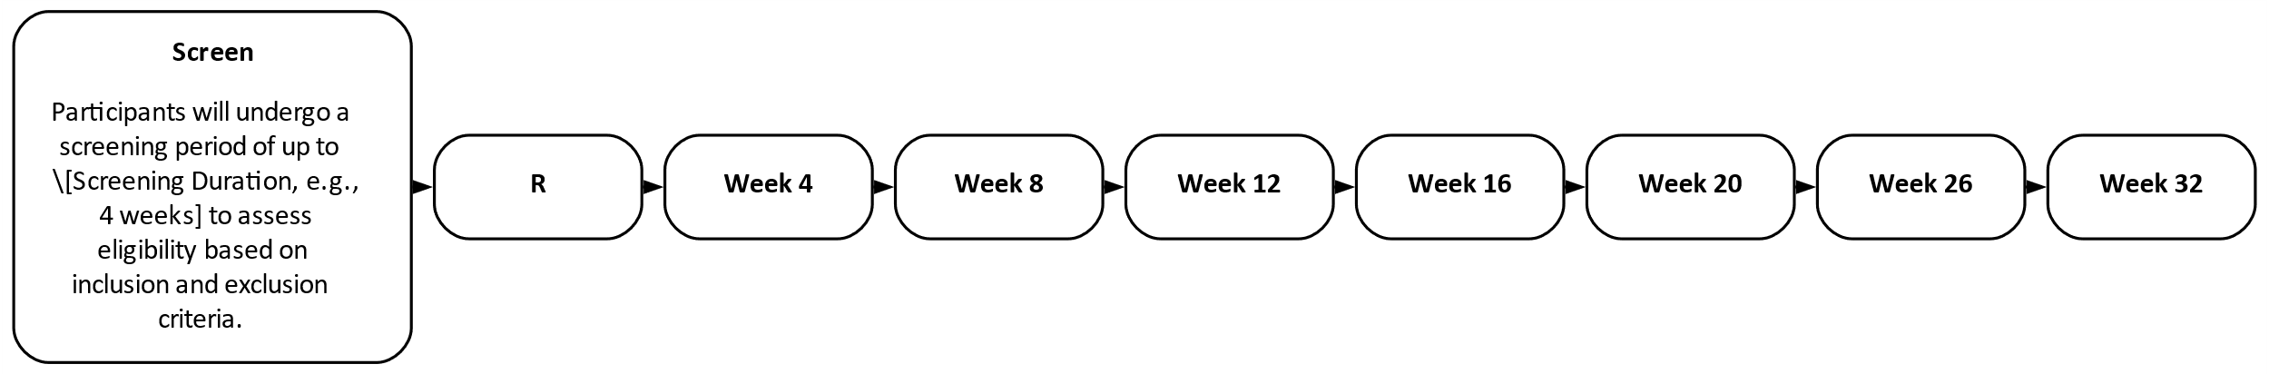

## Schedule of Activities (SoA)

|  |  |  |  |  |  |  |  |  |
| --- | --- | --- | --- | --- | --- | --- | --- | --- |
| Activity | Screening[1] | Week 4 | Week 8 | Week 12 | Week 16 | Week 20 | Week 26 | Week 32 |
| IC[2] | X |  |  |  |  |  |  |  |
| MH[3] | X |  |  |  |  |  |  |  |
| PE[4] | X | X | X | X | X | X | X | X |
| VS[5] | X | X | X | X | X | X | X | X |
| ECGs[6] | X |  | X |  |  |  | X | X |
| AE Mon[7] |  | X | X | X | X | X | X | X |
| BT[8] | X | X | X | X | X | X | X | X |
| HbA1c[9] | X |  |  |  |  |  | X | X |

Abbreviations: AE Mon = adverse event monitoring; BT = blood tests; ECGs = electrocardiograms; HbA1c = glycated hemoglobin; IC = informed consent; MH = medical history; PE = physical examination; VS = vital signs.

# Introduction

Type 2 Diabetes Mellitus (T2DM) is a chronic metabolic disorder characterized by persistent hyperglycemia due to insulin resistance and impaired pancreatic β-cell function. The global prevalence of T2DM is rising, significantly contributing to morbidity and mortality. Complications include microvascular issues like retinopathy and macrovascular problems such as cardiovascular disease. Current treatments often fail to achieve target glycated hemoglobin (HbA1c) levels due to factors like medication adherence and disease progression.

Glucagon-like peptide-1 (GLP-1) receptor agonists have shown promise in managing T2DM by enhancing insulin secretion, suppressing glucagon, and promoting satiety. KINE, a novel GLP-1 receptor agonist, was developed to improve upon existing therapies with enhanced receptor affinity and an extended half-life, allowing for once-weekly dosing. Preclinical studies indicated significant glucose reductions and weight benefits.

This Phase III, randomized, double-blind, placebo-controlled trial aims to evaluate the efficacy and safety of KINE in adults with T2DM inadequately controlled on current therapies. The study involves a 26-week treatment phase with KINE or placebo, followed by a 6-week follow-up. The primary objective is to assess the reduction in HbA1c levels, with secondary objectives including effects on fasting plasma glucose, body weight, and safety.

## Study Rationale

Type 2 Diabetes Mellitus (T2DM) is a chronic metabolic disorder characterized by insulin resistance and impaired pancreatic β-cell function, leading to persistent hyperglycemia. The global prevalence of T2DM has been rising, contributing significantly to morbidity and mortality worldwide. Current therapeutic strategies include lifestyle modifications and pharmacological interventions such as metformin, sulfonylureas, GLP-1 receptor agonists, and insulin therapy. Despite these options, many patients do not achieve or maintain optimal glycated hemoglobin (HbA1c) levels due to factors like suboptimal medication adherence, adverse side effects, and the progressive nature of the disease.

GLP-1 receptor agonists have emerged as effective treatments for T2DM by enhancing glucose-dependent insulin secretion, suppressing inappropriate glucagon secretion, slowing gastric emptying, and promoting satiety, which can aid in weight reduction. These mechanisms contribute to improved glycemic control with a lower risk of hypoglycemia compared to some other antidiabetic agents. KINE, a novel GLP-1 receptor agonist, is designed to offer enhanced receptor affinity and an extended half-life, enabling once-weekly subcutaneous administration. This dosing regimen may improve patient adherence and convenience, addressing limitations associated with more frequent dosing schedules of existing GLP-1 therapies.

Preclinical studies indicate that KINE effectively reduces fasting and postprandial glucose levels, improves insulin sensitivity, and promotes weight loss. Its pharmacokinetic profile demonstrates stable plasma concentrations with minimal fluctuations, potentially minimizing gastrointestinal side effects commonly associated with GLP-1 receptor agonists. Conducting a Phase III randomized, double-blind, placebo-controlled trial with parallel assignment will provide comprehensive data on the efficacy and safety of KINE in adults with T2DM. By evaluating KINE’s impact on HbA1c levels, fasting plasma glucose, body weight, and safety parameters, this study aims to determine its potential as a superior treatment option, thereby addressing unmet needs in the management of T2DM.

## Background

Type 2 Diabetes Mellitus (T2DM) is a chronic metabolic disorder characterized by sustained hyperglycemia resulting from insulin resistance and inadequate insulin secretion by pancreatic β-cells. The global prevalence of T2DM has been rising steadily, posing significant challenges to public health systems due to its association with severe microvascular and macrovascular complications, including retinopathy, nephropathy, neuropathy, cardiovascular disease, and stroke. These complications lead to increased morbidity, mortality, and substantial economic burdens.

Current therapeutic strategies for T2DM primarily involve lifestyle modifications and pharmacological interventions aimed at improving glycemic control. Standard treatments include metformin, sulfonylureas, thiazolidinediones, DPP-4 inhibitors, SGLT2 inhibitors, and insulin therapy. Despite the availability of these medications, many patients fail to achieve optimal glycated hemoglobin (HbA1c) levels. Factors contributing to this suboptimal control include medication adherence issues due to complex dosing schedules, adverse side effects such as hypoglycemia and weight gain, and the progressive nature of the disease leading to diminishing β-cell function over time.

Glucagon-like peptide-1 (GLP-1) receptor agonists have emerged as an effective class of drugs for T2DM management. GLP-1 enhances glucose-dependent insulin secretion, suppresses inappropriate glucagon release, slows gastric emptying, and promotes satiety, which can aid in weight reduction. These mechanisms contribute to improved glycemic control with a lower risk of hypoglycemia compared to some other antidiabetic agents.

KINE is a novel GLP-1 receptor agonist developed to overcome limitations associated with existing GLP-1 therapies. Engineered with enhanced receptor affinity, KINE is designed to exert more potent biological effects at lower doses. Additionally, its extended half-life allows for once-weekly subcutaneous administration, which may enhance patient adherence and convenience, crucial factors in the long-term management of T2DM. Preclinical studies have demonstrated that KINE significantly reduces fasting and postprandial glucose levels, improves insulin sensitivity, and contributes to weight loss. Its pharmacokinetic profile ensures stable plasma concentrations with minimal fluctuations, potentially reducing gastrointestinal side effects commonly observed with other GLP-1 receptor agonists.

Given the promising preclinical results, it is essential to evaluate the efficacy and safety of KINE in a robust clinical setting. This Phase III randomized, double-blind, placebo-controlled study aims to assess the therapeutic potential of KINE in adults aged 18 to 75 years with T2DM inadequately controlled on existing therapies. By leveraging its enhanced receptor affinity and prolonged action, KINE has the potential to provide superior glycemic control, weight management benefits, and improved patient compliance, addressing unmet needs in the current treatment landscape of T2DM.

## Benefit/Risk Assessment

The investigational drug KINE offers significant potential benefits, including improved glycemic control as evidenced by reductions in hemoglobin A1c levels and weight loss, which may contribute to overall health and decrease the risk of diabetes-related complications. The once-weekly subcutaneous administration is expected to enhance patient adherence compared to more frequent dosing regimens. Additionally, KINE’s enhanced receptor affinity and extended half-life may provide more stable plasma concentrations, potentially reducing gastrointestinal side effects commonly associated with GLP-1 receptor agonists.

However, potential risks associated with KINE include gastrointestinal adverse effects such as nausea and vomiting, which may impact patient tolerability and adherence to the treatment regimen. These side effects are consistent with those observed in other GLP-1 receptor agonists. Despite these risks, the anticipated benefits in managing Type 2 Diabetes Mellitus and improving patient compliance are considered to outweigh the potential adverse effects. Comprehensive monitoring and supportive measures will be implemented to mitigate these risks and ensure patient safety throughout the study.

### Risk Assessment

Participants may experience gastrointestinal adverse events, including nausea and vomiting, which are commonly associated with GLP-1 receptor agonists. Injection site reactions, such as pain, redness, or swelling, may occur following the subcutaneous administration of KINE. There is a potential risk of hypoglycemia, particularly in participants concurrently using other antidiabetic agents, although the risk is expected to be lower with KINE due to its glucose-dependent mechanism of action. Pancreatitis, although rare, is a serious potential risk associated with GLP-1 receptor agonists and will be closely monitored throughout the study. Participants with impaired renal function are excluded to mitigate the risk of adverse renal outcomes. Additionally, the double-blind design may delay the identification and management of severe adverse events, but the independent Data Safety Monitoring Board (DSMB) will oversee safety data to promptly address any significant risks. Cardiovascular events are considered unlikely due to the exclusion of participants with significant cardiovascular disease. Overall, the risk assessment highlights gastrointestinal disturbances, injection site reactions, hypoglycemia, and pancreatitis as primary concerns, with appropriate monitoring and exclusion criteria in place to manage and mitigate these risks.

### Benefit Assessment

The proposed Phase III interventional study aims to evaluate the therapeutic benefits of KINE, a novel GLP-1 receptor agonist, in the treatment of Type 2 Diabetes Mellitus (T2DM). KINE's administration of 1.5 mg subcutaneously once weekly offers a potentially improved adherence profile compared to daily dosing regimens, which is critical for chronic disease management. The randomized, double-blind, parallel assignment design with two arms ensures robust assessment of efficacy and safety outcomes. By targeting a broad population of adults aged 18 to 75 years with T2DM, the study results will be generalizable to a wide patient demographic.

KINE is anticipated to provide significant reductions in glycated hemoglobin (HbA1c) levels and facilitate weight loss, addressing two key aspects of T2DM management. Its enhanced receptor affinity and extended half-life may result in more consistent glycemic control and fewer gastrointestinal side effects, which are common challenges with existing GLP-1 therapies. The comprehensive evaluation of primary and secondary endpoints, including fasting plasma glucose, body mass index, and β-cell function, will elucidate KINE's overall impact on metabolic parameters and disease progression.

Furthermore, the study's rigorous inclusion and exclusion criteria ensure the selection of a population that is representative of real-world patients while minimizing confounding factors. The integration of a 26-week treatment phase followed by a 6-week follow-up allows for the assessment of both short-term efficacy and the durability of treatment effects. Ethical considerations and stringent data management protocols underpin the study's integrity, ensuring that the potential benefits of KINE are thoroughly and reliably evaluated. If successful, KINE could offer a significant advancement in T2DM treatment by enhancing glycemic control, promoting weight loss, and improving patient adherence through a convenient once-weekly dosing schedule.

### Overall Benefit Risk Conclusion

The Phase III study of KINE, a novel GLP-1 receptor agonist, aims to assess its efficacy and safety in treating Type 2 Diabetes Mellitus. KINE's once-weekly dosing may enhance adherence compared to daily regimens. Anticipated benefits include significant HbA1c reduction and weight loss, with fewer gastrointestinal side effects due to its enhanced receptor affinity and extended half-life. The randomized, double-blind design ensures robust evaluation, while exclusion criteria mitigate risks such as pancreatitis and hypoglycemia. If successful, KINE could significantly advance T2DM management by improving glycemic control and patient adherence.

# Objectives, Endpoints, and Estimands

|  |  |
| --- | --- |
| Objectives | Endpoints |
| Primary |  |
| To evaluate the efficacy of KINE in reducing glycated hemoglobin (HbA1c) levels over 26 weeks compared to placebo in adults with Type 2 Diabetes Mellitus. | Change in glycated hemoglobin (HbA1c) from baseline to Week 26. |
| Secondary |  |
| To assess the effect of KINE on fasting plasma glucose levels. | Change in fasting plasma glucose from baseline to Week 26. |
| To evaluate changes in body weight and body mass index (BMI). | Change in body weight and body mass index (BMI) from baseline to Week 26. |
| To assess the safety and tolerability of KINE over the study period. | Incidence and severity of adverse events and serious adverse events. |
| To evaluate the impact on β-cell function and insulin sensitivity. | Assessment of β-cell function and insulin sensitivity. |
| Tertiary |  |
| To assess the incidence and severity of adverse events and serious adverse events. | Changes in vital signs, clinical laboratory tests, and electrocardiograms (ECGs). |
| To evaluate changes in vital signs, clinical laboratory tests, and electrocardiograms (ECGs). |  |

# Study Design

## Overall Design

## Scientific Rationale for Study Design

### Patient Input into Design

## Justification for Dose

## End-of-Study Definition

# Study Population

## Inclusion Criteria

Participants are eligible to be included in the study only if all of the following criteria apply:

Age

Click or tap here to enter text.

Type of Participant and Disease Characteristics

Click or tap here to enter text.

Weight

Click or tap here to enter text.

Sex and Contraceptive/Barrier Requirements

All references to male & female pertain to sex assigned at birth, most often based on the infant’s physical characteristics.

Contraception, barriers, and pregnancy testing requirements: Contraception/abstinence and pregnancy testing requirements for a given study should be based upon a risk assessment of the potential for genotoxicity and teratogenicity/fetotoxicity of the study intervention(s) in the study. Risk should be determined for each study intervention with input from the company’s preclinical safety assessment group. Determination of risk for a marketed compound should also consider the risks outlined in the product label.

The common text language, per International Council on Harmonization [ICH] Guideline M3(R2) and Clinical Study Facilitation Group (CTFG) Guidance which supports EU536/2014, (<https://ec.europa.eu/health/sites/health/files/files/eudralex/vol-1/reg_2014_536/reg_2014_536_en.pdf>), should be used for most studies. The template language provided is intended to be sufficiently flexible to accommodate variability with local recommendation/regulation when defining appropriate contraception for the study.

NOTE: Use the Available Content panel in the eCPT to insert Contraception Language to ensure IE numbering remains intact.

The following Decision Trees and associated template language are based upon Committee for Medicinal Products for Human Use (CHMP) guidelines set forth in the CTFG Document: Recommendations related to contraception and pregnancy testing in clinical trials http://www.hma.eu/ctfg.html

Decision Tree for Contraception and Barriers

Review the following schema and determine the appropriate option for contraception and barrier methods based on the genotoxicity and teratogenicity/fetotoxicity of the study intervention(s) in the study; each outcome is aligned with corresponding template text options found in Sections 5.1 Inclusion Criteria, Section 8.2.5 Pregnancy Testing, Appendix 2 Clinical Laboratory Tests, and Appendix 4 Contraceptive and Barrier Guidance.

Modify the duration for contraception use by participants as appropriate for the study.

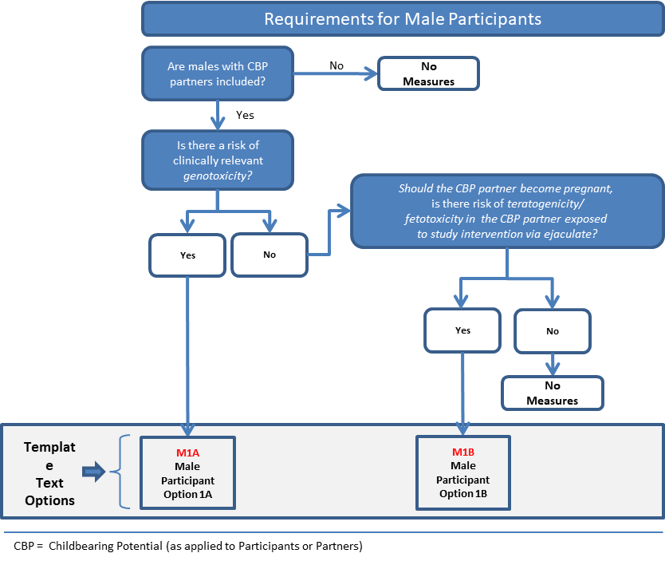

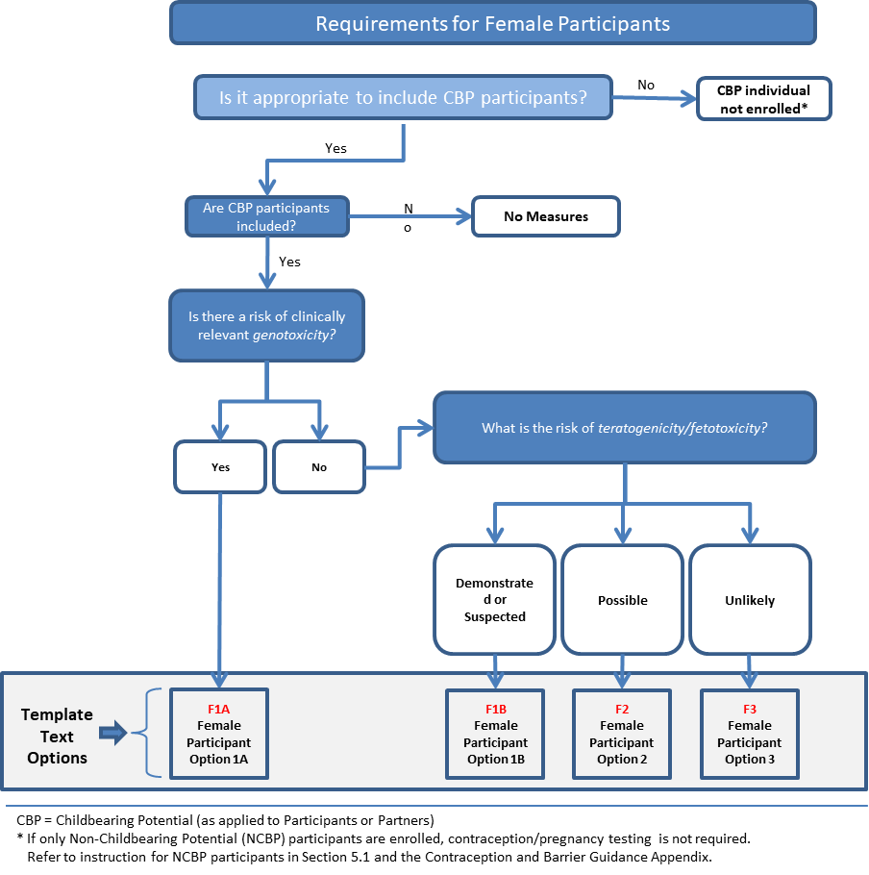

**MALE PARTICIPANTS**

Select one of the two following options for studies with male participants, unless there are no measures required for the study. (All references to male & female pertain to sex assigned at birth, most often based on the infant’s physical characteristics.)

**Option M1A:** For all studies in which the decision tree is Yes forclinically relevant genotoxicity**,** in addition to external condom use, a highly effective method of contraception should be used by CBP partners to prevent any potential for fertilization by sperm that contain damaged DNA due to the study intervention. CTFG recommendations suggest to consider contraception methods for the partner able to give birth.

Contraception methods outlined below are required from the beginning of study intervention through the period where CBP partners no longer need protection from seminal study intervention exposure (eg, X days/weeks, corresponding to time needed to eliminate study intervention(s) (eg, 5 terminal half-lives) plus an additional 90 days (a spermatogenesis cycle).

Note: In cases where there is potential for additional toxicity associated with exposure through ejaculate beyond those risks specifically assessed for genotoxicity and teratogenicity/fetotoxicity above, condom use should also be considered when engaging in activities with any partner (regardless of gender or sex) to prevent potential passage of study intervention in the ejaculate.

<Start of common text>

1. Male Participants:

Participants are eligible to participate if they agree to the following during the study intervention period and for at least [X days/weeks after the last dose of study intervention]:

* Refrain from donating sperm

PLUS, either:

* 1. Be abstinent from intercourse where pregnancy can occur (abstinent on a long term and persistent basis) and agree to remain abstinent

OR

* 1. Must agree to use [contraception /barrier] as detailed below
     1. Agree to use an external condom [with CBP partner use of an additional highly effective contraceptive method with a failure rate of < 1% per year as described in Appendix 4 Contraceptive and Barrier Requirements] OR [and should also be advised of the benefit for a partner of childbearing potential to use a highly effective method of contraception as a condom may break or leak] when having sexual intercourse with a partner able to give birth who is not currently pregnant
     2. [Agree to use an external condom when engaging in any activity that allows for passage of ejaculate to another person]

<End of common text>

**Option M1B:** For all studies in which the decision tree is Yes for‘Should the CBP partner become pregnant, is there risk of teratogenicity/fetotoxicity to the fetus in the partner exposed to study intervention via ejaculate?’**,** in addition to external condom use, a highly effective method of contraception may be considered in CBP partners to prevent passage of study intervention through the ejaculate, eg, when a male is sexually active with a partner able to give birth or one who is pregnant; however, this is not a requirement based upon CTFG recommendations.

Contraception methods outlined below are required from the beginning of study intervention through the period where CBP partners of male participants no longer need protection from seminal study intervention exposure (eg, X days/weeks, corresponding to time needed to eliminate study intervention(s) (eg, 5 terminal half-lives) after the last dose of study intervention).

Note: In cases where there is potential for additional toxicity associated with exposure through ejaculate beyond those risks specifically assessed for genotoxicity and teratogenicity/fetotoxicity above, condom use should also be considered when engaging in activities with any partner (different or same sex) to prevent potential passage of study intervention in the ejaculate.

<Start of common text>

1. Male Participants:

Participants are eligible to participate if they agree to the following during the study intervention period and for at least [X days/weeks after the last dose of study intervention]:

* Refrain from donating fresh unwashed semen

Plus either:

* 1. Be abstinent from intercourse where pregnancy can occur (abstinent on a long term and persistent basis) and agree to remain abstinent

OR

* 1. Must agree to use contraception/barrier as detailed below
     1. Agree to use an external condom [and should also be advised of the benefit for a CBP partner to use a highly effective method of contraception as a condom may break or leak] when having sexual intercourse with a partner able to give birth who is not currently pregnant
     2. [Agree to use an external condom when engaging in any activity that allows for passage of ejaculate to another person]

<End of common text>

**FEMALE PARTICIPANTS**

Select one of the following text options for studies with female participants. (All references to male & female pertain to sex assigned at birth, most often based on the infant’s physical characteristics)

**All Options:** For studies that have requirements for multiple pregnancy tests, add additional criteria as needed (eg, if there is a requirement for test to be performed within a proximal time frame prior to first dose, specify as inclusion criteria, if at a specified visit, or at end of study intervention note in Section 1.3 SoA and provide any necessary details in Section 8.2.5 Pregnancy Testing.

A serum pregnancy test may diagnose pregnancy ~6 to 10 days after fertilization; a urine pregnancy test, because it is less sensitive, will diagnose pregnancy a few days after a serum pregnancy test. As serum pregnancy tests have a lower detection limit and will detect pregnancy closer to the date of conception, serum testing is the preferred test if there is a requirement to know pregnancy status within a few days of the first dose of study intervention.

**Option F1A:** For all studies in which the decision tree is Yes for risk of clinically relevant genotoxicity:

Contraception methods outlined below are required from the beginning of study intervention through the period where CBP participants no longer need protection from becoming pregnant (X days/weeks, corresponding to the time needed to eliminate any study intervention(s) (eg, 5 terminal half-lives) plus 30 days (a menstrual cycle) after the last dose of study intervention.)

If there is effect of the study intervention on ova, specify that participants should not donate eggs, and include the timeframe given for donation restriction.

Note: for this option, CTFG guidelines state that highly effective contraception ***with low user dependency*** is preferred. If the study will ***require*** methods to have low user dependency remove the word ‘preferably‘ from bullets in common text.

If urine pregnancy test allowed, retain the text listed in the last blue bracketed bullet.

<Start of common text>

1. Female Participants:

* A participant is eligible to participate if not pregnant or breastfeeding, and one of the following conditions applies:
  1. Is of nonchildbearing potential (NCBP) as defined in [Appendix 4. Contraception and Barrier Guidance].

OR

* 1. Is of childbearing potential (CBP) and using a contraceptive method that is highly effective (with a failure rate of < 1% per year), [preferably] with low user dependency, as described in [Appendix 4. Contraception and Barrier Guidance] during the study intervention period and for at least [X days/weeks] after the last dose of study intervention [and agrees not to donate eggs (ova, oocytes) for the purpose of reproduction during this period.]. The investigator should evaluate the potential for contraceptive method failure (eg, noncompliance, recently initiated) in relationship to the first dose of study intervention.
* A CBP participant must have a negative highly sensitive pregnancy test ([urine or serum]) as required by local regulations) within [24 hours] before the first dose of study intervention, see Section [8.2.5 Pregnancy Testing].
  1. [If a urine test cannot be confirmed as negative (eg, an ambiguous result), a serum pregnancy test is required. In such cases, the participant must be excluded from participation if the serum pregnancy result is positive.]
* Additional requirements for pregnancy testing during and after study intervention are located in Section [8.2.5 Pregnancy Testing].
* The investigator is responsible for review of medical history, menstrual history, and recent sexual activity where pregnancy can occur to decrease the risk for inclusion of a participant with an early undetected pregnancy.

<End of common text>

**Option F1B:** For all studies in which the decision tree is Yes for demonstrated or suspected risk of human teratogenicity/fetotoxicity.

Contraception methods outlined below are required from the beginning of study intervention through the period where CBP participants no longer need protection from becoming pregnant (eg, X days/weeks, corresponding to the time needed to eliminate any study intervention(s) (eg, 5 terminal half-lives) after the last dose of study intervention).

Note: for this option, CTFG guidelines state that highly effective contraception ***with low user dependency*** is preferred. If the study will ***require*** methods to have low user dependency remove the word ‘preferably’ from the bullets in the common text.

If urine pregnancy test allowed, retain the text listed in the last blue bracketed bullet.

<Start of common text>

1. Female Participants:

* A participant is eligible to participate if not pregnant or breastfeeding, and one of the following conditions applies:
  1. Is of nonchildbearing potential (NCBP) as defined in [Appendix 4 Contraception and Barrier Guidance]

OR

* 1. Is of childbearing potential (CBP) and using a contraceptive method that is highly effective (with a failure rate of < 1% per year), [preferably] with low user dependency, as described in [Appendix 4. Contraception and Barrier Guidance] during the study intervention period and for at least [X days/weeks] after the last dose of study intervention. The investigator should evaluate the potential for contraceptive method failure (eg, noncompliance, recently initiated) in relationship to the first dose of study intervention.
* A CBP participant must have a negative highly sensitive pregnancy test ([urine or serum]) as required by local regulations) within [24 hours] before the first dose of study intervention, see [8.2.5 Pregnancy Testing].
  1. [If a urine test cannot be confirmed as negative (eg, an ambiguous result), a serum pregnancy test is required. In such cases, the participant must be excluded from participation if the serum pregnancy result is positive].
* Additional requirements for pregnancy testing during and after study intervention are located in Section [8.2.5 Pregnancy Testing].
* The investigator is responsible for review of medical history, menstrual history, and recent sexual activity where pregnancy can occur to decrease the risk for inclusion of a participant with an early undetected pregnancy.

<End of common text>

**Option F2:** For all studies in which the decision tree is Yes for possible risk of human teratogenicity/fetotoxicity.

Contraception methods outlined below are required from the beginning of study intervention through the period where CBP participants no longer need protection from becoming pregnant (eg, X days/weeks, corresponding to the time needed to eliminate any study intervention(s) (eg, 5 terminal half-lives)] after the last dose of study intervention).

If urine pregnancy test allowed, retain the text listed in the last blue bracketed bullet.

Female Participants:

<Start of common text>

1. Female Participants:

* A participant is eligible to participate if not pregnant or breastfeeding, and one of the following conditions applies:
  1. Is of nonchildbearing potential (NCBP) as defined in [Appendix 4 Contraceptive and Barrier Guidance].

OR

* 1. Is of childbearing potential (CBP) and using a contraceptive method that is highly effective, with a failure rate of < 1%, as described in [Appendix 4 Contraceptive and Barrier Guidance] during the study intervention period and for at least [X days/weeks] after the last dose of study intervention. The investigator should evaluate the potential for contraceptive method failure (eg, noncompliance, recently initiated) in relationship to the first dose of study intervention.
* A CBP participant must have a negative highly sensitive pregnancy test (urine or serum as required by local regulations) within [specify timeframe] before the first dose of study intervention, see Section [8.2.5 Pregnancy Testing].
  1. [If a urine test cannot be confirmed as negative (eg, an ambiguous result), a serum pregnancy test is required. In such cases, the participant must be excluded from participation if the serum pregnancy result is positive].
* Additional requirements for pregnancy testing during and after study intervention are located in Section [8.2.5 Pregnancy Testing].
* The investigator is responsible for review of medical history, menstrual history, and recent sexual activity where pregnancy can occur to decrease the risk for inclusion of a participant with an early undetected pregnancy.

<End of common text>

**Option F3:** For all studies in which the decision tree is Yes for unlikely risk of human teratogenicity/fetotoxicity.

Contraception methods outlined below are required from the beginning of study intervention through the period where CBP participants no longer need protection from becoming pregnant (at a minimum until after the last dose of study intervention).

If urine pregnancy test allowed, retain the text listed in the last blue bracketed bullet.

<Start of common text>

1. Female Participants:

* A participant is eligible to participate if not pregnant or breastfeeding, and one of the following conditions applies:
  1. Is of nonchildbearing potential (NCBP) as defined in [Appendix 4 Contraceptive and Barrier Guidance]

OR

* 1. Is of childbearing potential (CBP) and using an acceptable contraceptive method as described in [Appendix 4 Contraceptive and Barrier Guidance] during the study intervention period (at a minimum until after the last dose of study intervention). The investigator should evaluate the potential for contraceptive method failure (eg, noncompliance, recently initiated) in relationship to the first dose of study intervention.
* A CBP participant must have a negative highly sensitive pregnancy test (urine or serum as required by local regulations) within [specify timeframe] before the first dose of study intervention, see Section [8.2.5 Pregnancy Testing].
  1. [If a urine test cannot be confirmed as negative (eg, an ambiguous result), a serum pregnancy test is required. In such cases, the participant must be excluded from participation if the serum pregnancy result is positive].
* Additional requirements for pregnancy testing during and after study intervention are located in Section [8.2.5 Pregnancy Testing].
* The investigator is responsible for review of medical history, menstrual history, and recent sexual activity where pregnancy can occur to decrease the risk for inclusion of a participant with an early undetected pregnancy.

<End of common text>

**NCBP Studies only:** Select this criterion if female participants are required to be of nonchildbearing potential (NCBP) (in the absence of teratogenicity/fetotoxicity data or if reproductive toxicity data does not otherwise support the inclusion of CBP participants), no pregnancy testing or contraception methods are required.

<Start of common text>

1. Female Participants:

* A participant is eligible to participate if:
  1. They are of nonchildbearing potential (NCBP), as defined in [Appendix 4: Contraceptive and Barrier Guidance].

<End of common text>

Informed Consent

Other Inclusion Criteria

## Exclusion Criteria

Participants are excluded from the study if any of the following criteria apply:

Medical Conditions

Prior/Concomitant Therapy

Prior/Concurrent Clinical Study Experience

Diagnostic Assessments

Other Exclusion Criteria

## Lifestyle Considerations

### Meals and Dietary Restrictions

### Caffeine, Alcohol, and Tobacco

### Activity

### Other Restrictions

## Screen Failures

<Start of common text>

A screen failure occurs when a participant who has consented to participate in the clinical study is not subsequently [assigned to study intervention/entered in the study]. A minimal set of screen failure information is required to ensure transparent reporting of screen failure participants to meet the CONSORT publishing requirements and to respond to queries from regulatory authorities. Minimal information includes demography, screen failure details, eligibility criteria, and any SAE.

<End of common text>

<Start of common text>

Individuals who do not meet the criteria for participation in this study (screen failure) [may/may not] be rescreened. [Rescreened participants should be assigned a new participant number for every screening/rescreening event.]

<End of common text>

## Criteria for Temporarily Delaying

# Study Intervention(s) and Concomitant Therapy

<Start of common text>

Study interventions are all pre-specified, investigational and non-investigational medicinal products, medical devices and other interventions (eg, surgical and behavioral) intended to be administered to the study participants during the study conduct.

<End of common text>

## Study Intervention(s) Administered

<Start of suggested text>

Table . Study Intervention(s) Administered

|  |  |  |  |  |
| --- | --- | --- | --- | --- |
| **Intervention Label** |  |  |  |  |
| **Intervention Name** | [Generic (or trade name if required) as per CMC, if applicable, or sponsor number] | [Generic (or trade name if required) as per CMC, if applicable, or sponsor number] | [Placebo] | [Any additional products provided as part of the study including rescue medications or challenge agent] |
| **Intervention Description** | [eg, dosage form, dosage, frequency] | [eg, dosage form, dosage, frequency] | [eg, dosage form, dosage, frequency] | [eg, dosage form, dosage, frequency] |
| **Type** | [drug/device/biologic] | [drug/device/biologic] | [drug/device/biologic] | [drug/device/biologic] |
| **Dose Formulation** | [tablet/ampule/capsule] | [tablet/ampule/capsule] | [tablet/ampule/capsule] | [tablet/ampule/capsule] |
| **Unit Dose Strength(s)** | [dose strength of the product ie, each unit] | [dose strength of the product ie, each unit] | [dose strength of the product ie, each unit] | [dose strength of the product ie, each unit] |
| **Dosage Level(s)** | [dose amount and frequency] | [dose amount and frequency] | [dose amount and frequency] | [dose amount and frequency] |
| **Route of Administration** | [oral/IM/IV infusion/IV injection] | [oral/IM/IV infusion/IV injection] | [oral/IM/IV infusion/IV injection] | [oral/IM/IV infusion/IV injection] |
| **Use** | [experimental, placebo, active comparator, sham comparator, rescue medication, background intervention, challenge agent, diagnostic, or other] | [experimental, placebo, active comparator, sham comparator, rescue medication, background intervention, challenge agent, diagnostic, or other] | [experimental, placebo, active comparator, sham comparator, rescue medication, background intervention, challenge agent, diagnostic, or other] | [experimental, placebo, active comparator, sham comparator, rescue medication, background intervention, challenge agent, diagnostic, or other] |
| **IMP and NIMP/AxMP.** | IMP or NIMP | IMP or NIMP | IMP or NIMP | IMP or NIMP |
| **Sourcing** | [Insert/modify as appropriate: Provided centrally by the sponsor or locally by the study site, subsidiary, or designee. If device, list manufacturer] | [Insert/modify as appropriate: Provided centrally by the sponsor or locally by the study site, subsidiary, or designee. If device, list manufacturer] | [Insert/modify as appropriate: Provided centrally by the sponsor or locally by the study site, subsidiary, or designee. If device, list manufacturer] | [Insert/modify as appropriate: Provided centrally by the sponsor or locally by the study site, subsidiary, or designee. If device, list manufacturer] |
| **Packaging and Labeling** | Study intervention will be provided in [container]. Each [container] will be labeled as required per country requirement. | Study intervention will be provided in [container]. Each [container] will be labeled as required per country requirement. | Study intervention will be provided in [container]. Each [container] will be labeled as required per country requirement. | Study intervention will be provided in [container]. Each [container] will be labeled as required per country requirement. |
| **[Current/ Former Name(s) or Alias(es)]** | Current/former name(s) or alias(es) | Current/former name(s) or alias(es) | Current/former name(s) or alias(es) | Current/former name(s) or alias(es) |

Table 2. Study Arm(s)

|  |  |  |  |
| --- | --- | --- | --- |
| **Arm Title** | Enter Arm name | Enter Arm name | Enter Arm name |
| **Arm Type** | [experimental, placebo, active comparator, sham comparator, no intervention, or other] | [experimental, placebo, active comparator, sham comparator, no intervention, or other] | [experimental, placebo, active comparator, sham comparator, no intervention, or other] |
| **[Arm Description]** | [eg, Participants will receive [X] 20 mg BID on Day 1 of each 21-day cycle. [Z] will be administered on Day 1 for 4 cycles.] | [eg, Participants will receive [X] 20 mg BID on Day 1 of each 21-day cycle. [Z] will be administered on Day 1 for 4 cycles.] | [eg, Participants will receive [X] 20 mg BID on Day 1 of each 21-day cycle. [Z] will be administered on Day 1 for 4 cycles.] |
| **Associated Intervention Labels** |  |  |  |

<End of suggested text>

### Medical Devices

## Preparation, Handling, Storage, and Accountability

<Start of common text>

1. The investigator or designee must confirm appropriate conditions (eg, temperature) have been maintained during transit for all study intervention received, and any discrepancies are reported and resolved before use of the study intervention.
2. Only participants [randomized/assigned] to study intervention may receive study intervention, and only authorized site staff may supply, prepare, or administer study intervention.
3. All study intervention must be stored in a secure, environmentally controlled, and monitored (manual or automated) area in accordance with the labeled storage conditions with access limited to the investigator and authorized site staff.
4. The investigator, [institution, the head of the medical institution (where applicable), or authorized site staff] is responsible for study intervention accountability, reconciliation, and record maintenance (ie, receipt, reconciliation, and final disposition records).
5. Further guidance and information for the final disposition of unused study interventions are provided in the [study reference manual or other specified location].

<End of common text>

## Assignment to Study Intervention

## [Blinding, Masking]

<Start of example text>

|  |  |
| --- | --- |
| **Type of Study** | Example text to use |
| **Open-label, no blinding at site level** | This is an open-label study; potential bias will be reduced by the following steps: [central randomization, adjudications]. |
| **Open-label using central randomization via IVRS/IWRS** | This is an open-label study; however, the specific intervention to be taken by a participant will be assigned using an IVRS/IWRS. The site will contact the IVRS/IWRS prior to the start of study intervention administration for each participant. The site will record the intervention assignment on the applicable case report form, if required. Potential bias will be reduced by the following steps: [central randomization, adjudications]. |
| **Blind break (IVRS/IWRS)** | This is a double-blind study in which [participants/care providers/investigators/outcomes assessors, etc] are blinded to study intervention. The IVRS/IWRS will be programmed with blind-breaking instructions. In case of an emergency, the investigator has the sole responsibility for determining if unblinding of a participants’ intervention assignment is warranted. Participant safety must always be the first consideration in making such a determination. If the investigator decides that unblinding is warranted, the investigator may, at the investigator’s discretion, contact the sponsor to discuss the situation prior to unblinding a participant’s intervention assignment unless this could delay emergency treatment for the participant. If a participant’s intervention assignment is unblinded, the sponsor must be notified within 24 hours of this occurrence. The date and reason for the unblinding must be recorded. |
| **Open-label using blinded randomization** | This is an open-label study; however, the specific intervention to be taken by a participant will be assigned using randomization envelopes. The site will receive blinded randomization envelopes that will be opened in ascending numerical order immediately prior to the start of study intervention administration for each participant. The site will record the date and time the envelope was opened. |
| **Blind break (envelopes)** | This is a double-blind study in which [participants/care providers/investigators/outcomes assessors, etc] are blinded to study intervention. A sealed envelope that contains the study intervention assignment for each participant will be provided to the investigator. The sealed envelope will be retained by the investigator (or representative) in a secured area. In case of an emergency, the investigator has the sole responsibility for determining if unblinding of a participant’s intervention assignment is warranted. Participant safety must always be the first consideration in making such a determination. If the investigator decides that unblinding is warranted, the investigator may, at the investigator’s discretion, contact the sponsor to discuss the situation prior to unblinding a participant’s intervention assignment unless this could delay emergency treatment for the participant. If a participant’s intervention assignment is unblinded, the sponsor must be notified within 24 hours of this occurrence. Once the study is complete, all envelopes (sealed and opened) must be inventoried and returned to the sponsor. |
| **Blinded study with unblinded third party who is dispensing intervention** | Participants will be randomly assigned in a [1:1] ratio to receive study intervention. Investigators will remain blinded to each participant’s assigned study intervention throughout the course of the study. To maintain this blind, an otherwise uninvolved third party will be responsible for the reconstitution and dispensation of all study intervention and will endeavor to ensure that there are no differences in time taken to dispense following randomization.  This third party will instruct the [participant/participant’s parent(s) or legally authorized representative] to avoid discussing the taste, dosing frequency, or packaging of the study intervention with the investigator.  In the event of a quality assurance audit, the auditor(s) will be allowed access to unblinded study intervention records at the site(s) to verify that randomization/dispensing has been conducted accurately. |

Sponsor safety staff may unblind the intervention assignment for any participant with an SAE. If the SAE requires that an expedited regulatory report be sent to one or more regulatory agencies, a copy of the report, identifying the participant’s intervention assignment, may be sent to investigators in accordance with local regulations and/or sponsor policy.

<End of example text>

## Study Intervention Compliance

## Dose Modification

### Retreatment Criteria

## Continued Access to Study Intervention after the End of the Study

## Treatment of Overdose

## Prior and Concomitant Therapy

# Discontinuation of Study Intervention and Participant Discontinuation/Withdrawal

## Discontinuation of Study Intervention

### Liver Chemistry Stopping Criteria

Two sets of algorithms are provided for all phases to allow for elevations in ALT only or elevations in ALT or AST to be used as stopping criteria. The relevant option for the specific study should be selected and all others deleted.

Option A: ALT only

<Start of common text for Phase 1 studies>

Study intervention will be discontinued **for a participant** if liver event criteria are met.

**Phase 1 Liver Event Criteria Algorithm**

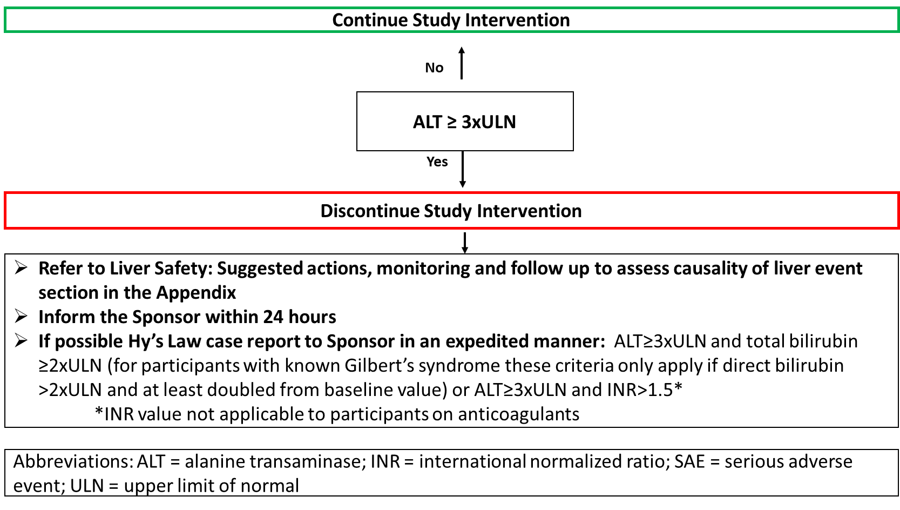

Refer to **Section 10.6.1 Liver Safety: Suggested actions, monitoring and follow up to assess causality of liver event**

<End of common text for Phase 1 studies>

<Start of common text for Phase 2 studies>

Study intervention will be discontinued **for a participant** if liver event criteria are met.

**Phase 2 Liver Event Criteria Algorithm**

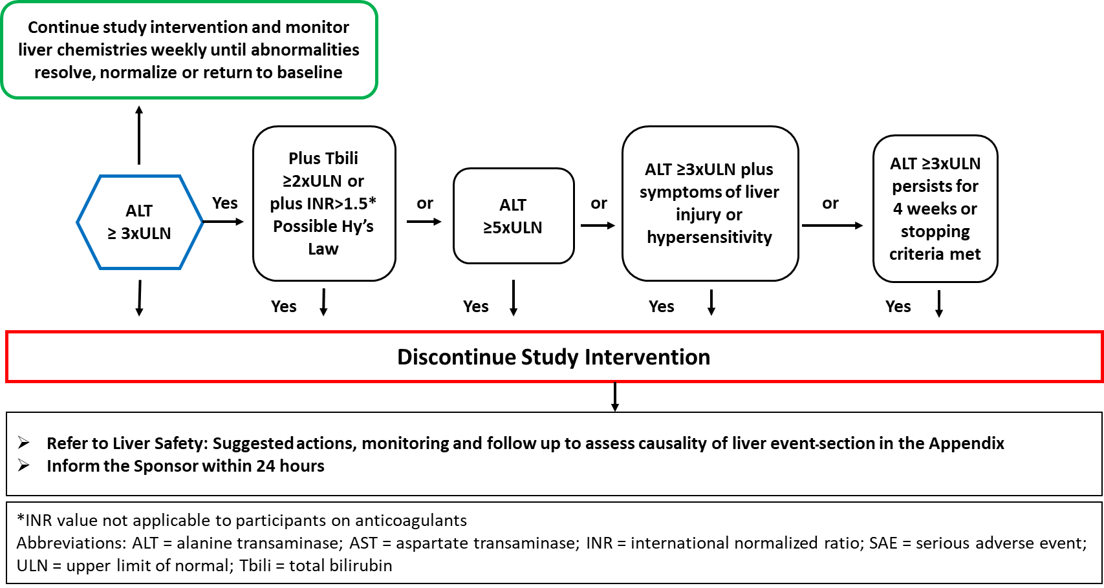

Refer to **Section 10.6.1 Liver Safety: Suggested actions, monitoring and follow up to assess causality of liver event.** Participants who do not meet protocol specified liver event stopping criteria but met protocol defined increased monitoring criteria may continue study intervention with increased liver chemistry monitoring. Refer to **Section 10.6.2: Liver Safety: Liver event increased monitoring criteria with continued study intervention.**

<End of common text for Phase 2 studies>

<Start of common text for Phase 3-4 studies>

Study intervention will be discontinued **for a participant** if liver event criteria are met.

**Phase 3-4 Liver Event Criteria Algorithm**

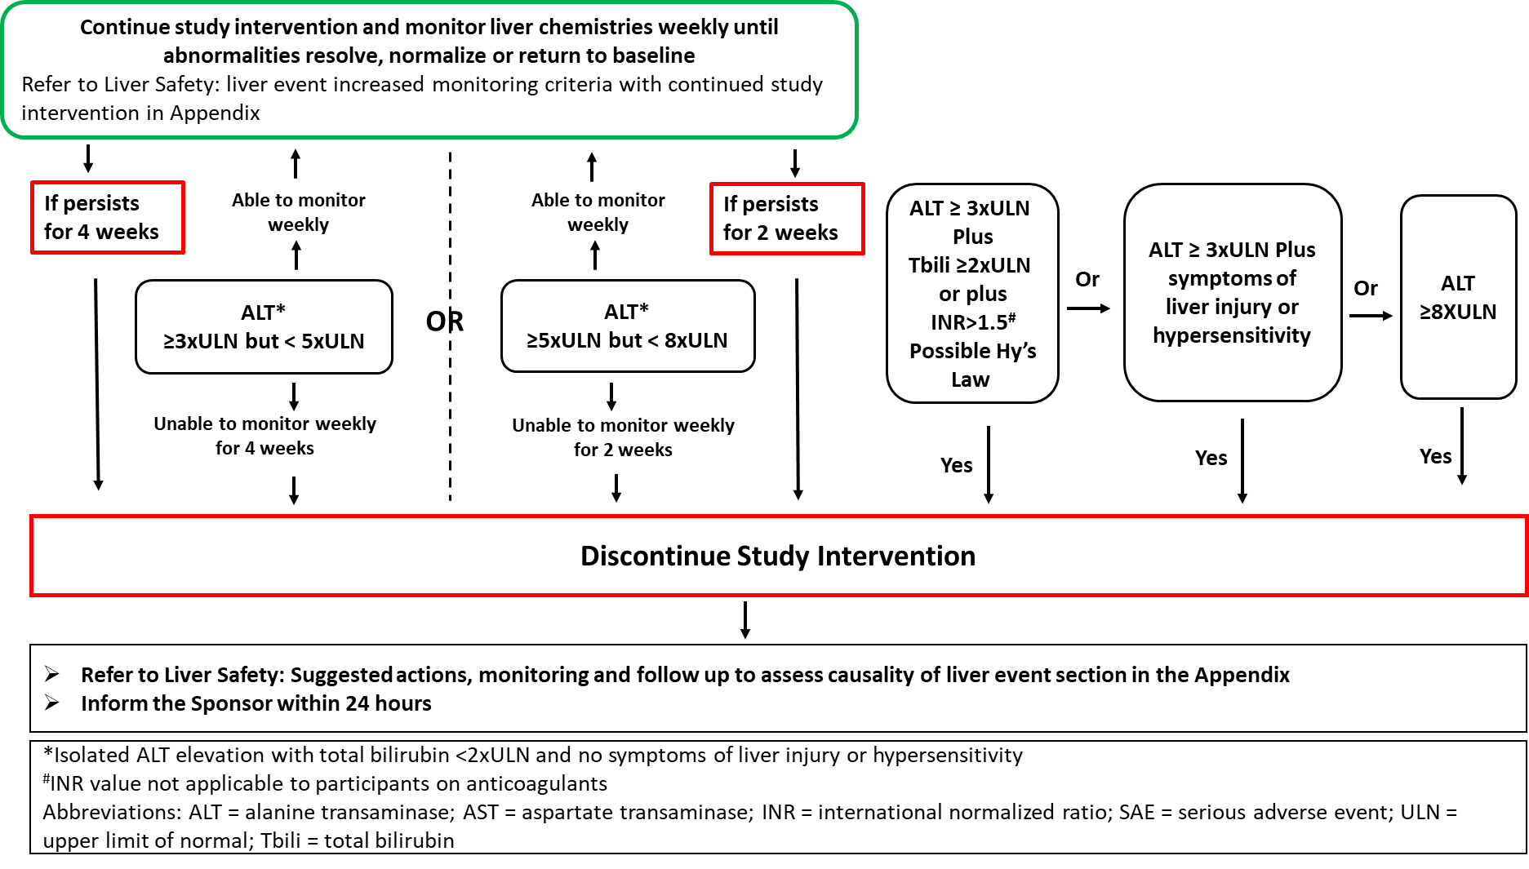

Refer to **Section 10.6.1 Liver Safety: Suggested actions, monitoring and follow-up to assess causality of liver event.** Participants who do not meet protocol specified liver event stopping criteria but met protocol defined increased monitoring criteria may continue study intervention with increased liver chemistry monitoring. Refer to **Section 10.6.2: Liver Safety: Liver event increased monitoring criteria with continued study intervention.**

<End of common text for Phase 3-4 studies>

**Option B: ALT or AST**

<Start of common text for Phase 1 studies>

Study intervention will be discontinued **for a participant** if liver event criteria are met.

**Phase 1 Liver Event Criteria Algorithm**

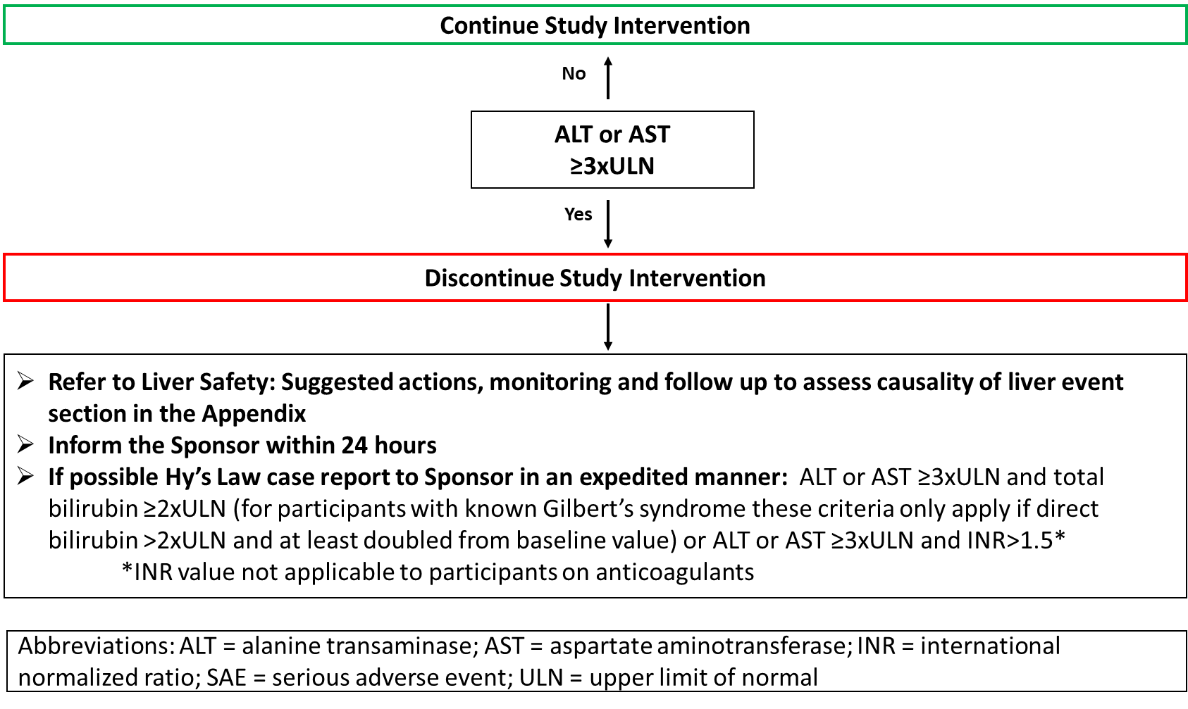

Refer to **Section 10.6.1 Liver Safety: Suggested actions, monitoring and follow up to assess causality of liver event**.

<End of common text for Phase 1 studies>

<Start of common text for Phase 2 studies>

Study intervention will be discontinued **for a participant** if liver event criteria are met.

**Phase 2 Liver Event Criteria Algorithm**

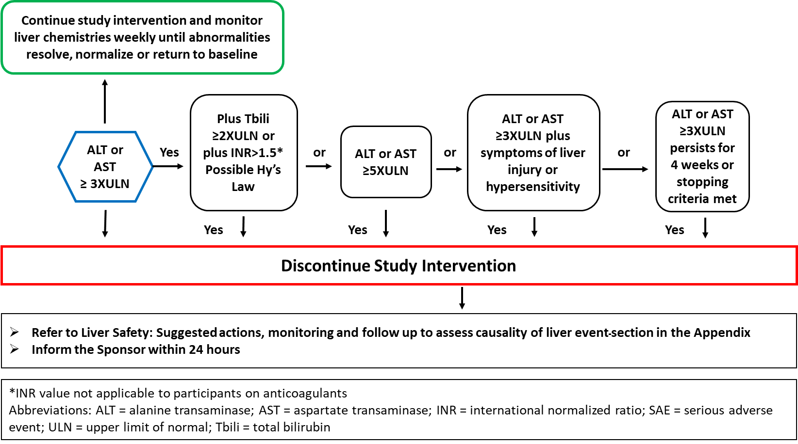

Refer to **Section 10.6.1 Liver Safety: Suggested actions, monitoring and follow up to assess causality of liver event**

Participants who do not meet protocol specified liver event stopping criteria but met protocol defined increased monitoring criteria may continue study intervention with increased liver chemistry monitoring. Refer to **Section 10.6.2 Liver Safety: Liver event increased monitoring criteria with continued study intervention**.

<End of common text for Phase 2 studies>

<Start of common text for Phase 3-4 studies>

Study intervention will be discontinued **for a participant** if liver event criteria are met.

**Phase 3-4 Liver Event Criteria**

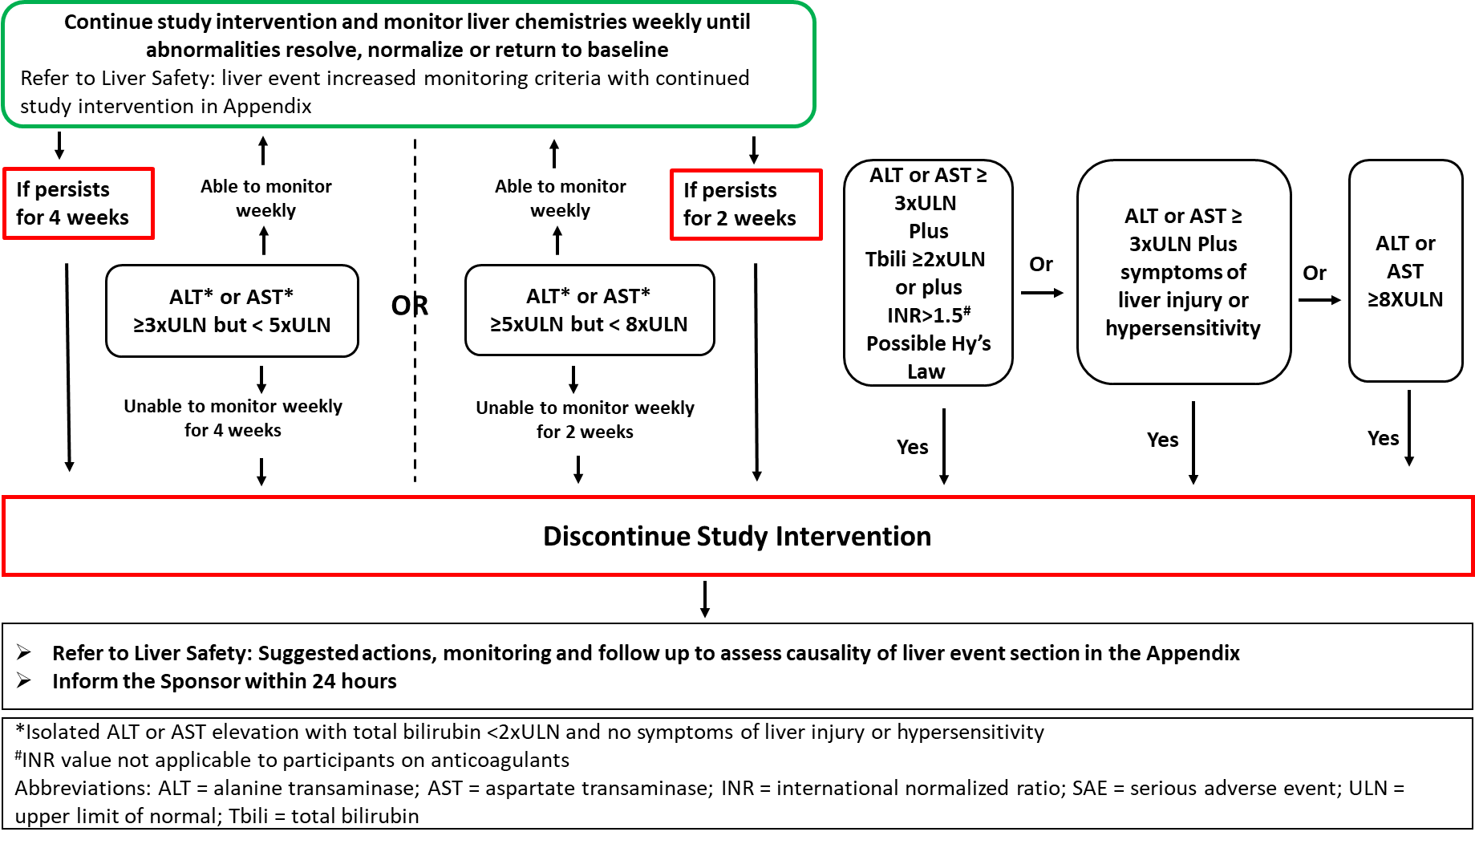

Refer to **Section 10.6.1 Liver Safety: Suggested actions, monitoring and follow up to assess causality of liver event.** Participants who do not meet protocol specified liver event stopping criteria but met protocol defined increased monitoring criteria may continue study intervention with increased (weekly) liver chemistry monitoring. Refer to **Section 10.6.2 Liver Safety: Liver event increased monitoring criteria with continued study intervention**.

<End of common text for Phase 3-4 studies>

### QTc Stopping Criteria

<Start of common text>

A participant who meets [the] OR [either] bulleted [criterion] OR [criteria] based on [single] OR [the average of triplicate] ECG readings will be withdrawn from study intervention.

<End of common text>

<Start of common text for Phase 1-4 studies>

* QTc > 500 msec OR Uncorrected QT > 600 msec [change from baseline of QTc > 60 msec]

For participants with underlying bundle branch block, follow the discontinuation criteria listed below:

|  |  |
| --- | --- |
| Baseline QTc with Bundle Branch Block | Discontinuation QTc Threshold with Bundle Branch Block |
| < 450 msec | > 500 msec |
| 450 to 480 msec | ≥ 530 msec |

<End of common text for Phase 1-4 studies>

### Temporary Discontinuation

### Rechallenge

#### Study Intervention Restart or Rechallenge After Liver Stopping Criteria Are Met

## Participant Discontinuation/Withdrawal from the Study

## Lost to Follow up

# Study Assessments and Procedures

<Start of common text>

* Study procedures and their timing are summarized in the SoA. Protocol waivers or exemptions are not allowed.
* Adherence to the study design requirements, including those specified in the SoA, is essential and required for study conduct.
* All screening evaluations must be completed and reviewed to confirm that potential participants meet all eligibility criteria. The investigator will maintain a screening log to record details of all participants screened and to confirm eligibility or record reasons for screening failure, as applicable.
* Procedures conducted as part of the participant’s routine clinical management [(eg, blood count)] and obtained before signing of the ICF may be utilized for screening or baseline purposes provided the procedures met the protocol-specified criteria and were performed within the timeframe defined in the SoA.
* In the event of a significant study-continuity issue (eg, caused by a pandemic), alternate strategies for participant visits, assessments, medication distribution and monitoring may be implemented by the sponsor or the investigator, as per local health authority/ethics requirements.
* [Safety/laboratory/analyte results] that could unblind the study will not be reported to investigative sites or other blinded personnel [until the study has been unblinded].
* Planned timepoints for all assessments are provided in the SoA.

<End of common text>

<Start of example text>

[The maximum amount of blood collected from each participant over the duration of the study, including any extra assessments that may be required, will not exceed [X] mL.]

[Repeat or unscheduled samples may be taken for safety reasons or for technical issues with the samples.]

<End of example text>

## Administrative [and General/Baseline] Procedures

## [Efficacy and/or Immunogenicity] Assessments

## Safety Assessments

### Physical Examinations

### Vital Signs

### Electrocardiograms

### Clinical Safety Laboratory Tests

### Pregnancy Testing

Select ONE of the options corresponding with the contraceptive option selected from the decision tree in section 5.1.

**Option F1A:**

For all studies in which the decision tree is Yes for clinically relevant genotoxicity (The decision tree is located in Section 5.1).

<Start of common text>

* Refer to Section 5.1 Inclusion Criteria for pregnancy testing entry criteria.
* Pregnancy testing (urine or serum as required by local regulations) should be conducted at monthly intervals during study intervention period.
* Pregnancy testing (urine or serum as required by local regulations) should be conducted at the end of relevant systemic exposure plus an additional 30 days and correspond with the time frame for female participant contraception in Section 5.1, Inclusion Criteria.
* Additional serum or urine pregnancy tests may be performed, as determined necessary by the investigator or required by local regulation, to establish the absence of pregnancy at any time during the participant’s participation in the study.

<End of common text>

**Option F1B:**

For all studies in which the decision tree is Yes for demonstrated or suspected risk of human teratogenicity/fetotoxicity (The decision tree is located in Section 5.1):

<Start of common text>

* Refer to Section 5.1 Inclusion Criteria for pregnancy testing entry criteria.
* Pregnancy testing (urine or serum as required by local regulations) should be conducted at monthly intervals during study intervention period.
* Pregnancy testing (urine or serum as required by local regulations) should be conducted at the end of relevant systemic exposure and correspond with the time frame for female participant contraception in Section 5.1, Inclusion Criteria.
* Additional serum or urine pregnancy tests may be performed, as determined necessary by the investigator or required by local regulation, to establish the absence of pregnancy at any time during the participant’s participation in the study.

<End of common text>

**Option F2:** For all studies in which the decision tree is Yes for possible risk of human teratogenicity/fetotoxicity (The decision tree is located in Section 5.1):

Additional pregnancy testing should be considered. As a minimum, pregnancy testing should be conducted at the end of relevant systemic exposure.

<Start of common text>

* Pregnancy testing (urine or serum as required by local regulations) should be conducted at [specify intervals based upon mechanism of action, study design etc.] during study intervention period.
* Pregnancy testing (urine or serum as required by local regulations) should be conducted at the end of relevant systemic exposure.
* Additional serum or urine pregnancy tests may be performed, as determined necessary by the investigator or required by local regulation, to establish the absence of pregnancy at any time during the participant’s participation in the study.

<End of common text>

**Option F3:** For all studies in which the decision tree is Yes for unlikely risk of human teratogenicity/fetotoxicity (The decision tree is located in Section 5.1):

Additional pregnancy testing following screening is generally not necessary.

<Start of common text>

* Refer to Section 5.1 Inclusion Criteria for pregnancy testing entry criteria.
* Additional serum or urine pregnancy tests may be performed, as determined necessary by the investigator or required by local regulation, to establish the absence of pregnancy at any time during the participant’s participation in the study.

<End of common text>

### Suicidal Ideation and Behavior Risk Monitoring

<Start of example text>

[STUDY INTERVENTION] is considered to be a CNS-active intervention.

AND/OR:

[STUDY INTERVENTION] is related to products with an increased risk of suicidal ideation or behavior.

AND/OR:

Patients with [CONDITION] may occasionally develop suicidal ideation or behavior.

<End of example text>

<Start of common text>

Participants being treated with [study intervention X] should be monitored appropriately and observed closely for suicidal ideation and behavior (SIB) or any other unusual changes in behavior, especially at the beginning and end of the course of intervention, or at the time of dose changes, either increases or decreases. Participants who experience signs of SIB should undergo a risk assessment. All factors contributing to SIB should be evaluated and consideration should be given to discontinuation of the study intervention.

<End of common text>

If study design calls for family and caregiver input, specify the need to communicate to these parties. For wording to be used in pediatric studies, see the pediatric participant library.

Specify how, if in the event of suicidal ideation or behavior, information will be shared with the legal guardian or others, including mental health professionals (local regulations should be followed). Address in the informed consent and assent forms as appropriate.

<Start of common text>

When informed consent or assent has been given, families and caregivers of participants being treated with [study intervention X] should be alerted about the need to monitor participants for the emergence of unusual changes in behavior, as well as the emergence of suicidal ideation and behavior and to report such symptoms immediately to the study investigator.

[Baseline assessment of suicidal ideation and behavior/intervention-emergent suicidal ideation and behavior] will be monitored during [study identifier] using [name of scale].

<End of common text>

## Adverse Events (AEs) Serious Adverse Events (SAEs), and Other Safety Reporting

<Start of common text>

The definitions of adverse events (AEs) and serious adverse events (SAEs) can be found in Appendix [3/7].

[The definitions of unsolicited and solicited adverse events can be found in Appendix 3].

[The definitions of device-related safety events, adverse device effects (ADEs), and serious adverse device effects (SADEs) can be found in Appendix 7. Device deficiencies are covered in Section 8.4.9.]

The investigator and any qualified designees are responsible for detecting, documenting, and recording events that meet the definition of an AE or SAE and remain responsible for following up [all AEs OR AEs that are serious, considered related to the study intervention or study procedures, or that caused the participant to discontinue the [study intervention] [study]] (see Section 7). This includes events reported by the participant (or, when appropriate, by a caregiver, surrogate, or the participant’s legally authorized representative).

The method of recording, evaluating, and assessing causality of AEs and SAEs and the procedures for completing and transmitting SAE reports are provided in Appendix [3/7].

<End of common text>

### Time Period and Frequency for Collecting AE and SAE Information

### Method of Detecting AEs and SAEs

### Follow-up of AEs and SAEs

### Regulatory Reporting Requirements for SAEs

### Pregnancy

### Cardiovascular and Death Events

### Disease-related Events and/or Disease-related Outcomes Not Qualifying as AEs or SAEs

### Adverse Events of Special Interest

### Medical Device Deficiencies

#### Time Period for Detecting Medical Device Deficiencies

#### Follow-up of Medical Device Deficiencies

#### Prompt Reporting of Device Deficiencies to the Sponsor

#### Regulatory Reporting Requirements for Device Deficiencies

## Pharmacokinetics

## Pharmacodynamics

## Genetics

## Biomarkers

## Immunogenicity Assessments

## [Health Economics OR Medical Resource Utilization and Health Economics]

# Statistical Considerations

## Statistical [Hypothesis/Hypotheses]

### Multiplicity Adjustment

## Analysis Sets

<Start of example text>

Example 1:

For the purposes of analysis, the following analysis sets are defined:

| **Participant Analysis Set** | **Description** |
| --- | --- |
| Full analysis set (FAS) | * All randomized participants. |
| Safety analysis set (SAS) | * All participants who are exposed to investigational intervention. |

The full analysis set will be used to analyze endpoints related to the efficacy objectives and the safety analysis set will be used to analyze the endpoints and assessments related to safety.

For the efficacy analyses, participants will be included in the analyses according to the planned investigational intervention; whereas for safety analyses, participants will be included in the analyses according to the investigational intervention they actually received.

Example 2:

The following analysis data sets are defined to estimate the estimands defined in the protocol and to address safety.

|  |  |
| --- | --- |
| **Analysis Data Sets** | **Description** |
| Analysis data set 1:  for the primary estimand and for the secondary estimand for the secondary objective 1 | PAS1: All randomized participants.  All data points obtained at or after randomization up to the earliest date of discontinuation of investigational intervention or administration of rescue therapy. |
| Analysis data set 2:  for the supplementary estimand for the primary objective | PAS1  All data points obtained at or after randomization up to the [end of study] visit. |
| Analysis data set 3:  for safety assessments with a long lag-time | PAS2: All participants who are exposed to investigational intervention.  All observed data. |
| Analysis data set 4:  for safety assessments with an acute onset | PAS2  All data points obtained at or after randomization until discontinuation of investigational intervention. |

PAS : participant analysis set

For the efficacy analyses, participants will be included in the analyses according to the planned investigational intervention; whereas for safety analyses, participants will be included in the analyses according to the investigational intervention they actually received.

Example 3:

The following participant analysis sets are defined:

| **Participant Analysis Set** | **Description** |
| --- | --- |
| Full analysis set (FAS) | All randomized participants. |
| Safety analysis set (SAS) | All participants who are exposed to investigational intervention. |

**The following data points sets are defined:**

| **Data Points Sets** | **Description** |
| --- | --- |
| DPS1 | All data points obtained at or after randomization up to the earliest date of discontinuation of investigational intervention or administration of rescue therapy. |
| DPS2 | All data points obtained at or after randomization up to the [end of study] visit. |
| DPS3 | All observed data. |
| DPS4 | All data points obtained at or after randomization until discontinuation of investigational intervention. |

DPS: Data Points Set

FAS and DPS1 will be used to estimate the primary estimand and the secondary estimand for secondary objective 1.

FAS and DPS2 will be used to estimate the supplementary estimand for the primary objective.

SAS and DPS3 will be used to present safety data with a long lag-time.

SAS and DPS4 will be used to present safety data with an acute onset.

For the efficacy analyses, participants will be included in the analyses according to the planned investigational intervention; whereas for safety analyses, participants will be included in the analyses according to the investigational intervention they actually received.

<End of example text>

## Statistical Analyses

### General Considerations

### Primary [Endpoint(s)/Estimand(s)] Analysis

#### Definition of Endpoint(s)

#### Main Analytical Approach

#### Sensitivity [Analysis/Analyses]

#### Supplementary [Analysis/Analyses]

### Secondary [Endpoint(s)/Estimand(s)] Analysis

### [Tertiary/Exploratory/Other] [Endpoint(s)/Estimand(s)] Analysis

### [Other] Safety Analyses

### Other Analyses

## Interim [Analysis/Analyses]

## Sample Size Determination

# Supporting Documentation and Operational Considerations

## Appendix 1: Regulatory, Ethical, and Study Oversight Considerations

### Regulatory and Ethical Considerations

* This study will be conducted in accordance with the protocol and with the following:
  + Consensus ethical principles derived from international guidelines including the Declaration of Helsinki and Council for International Organizations of Medical Sciences (CIOMS) international ethical guidelines
  + Applicable ICH Good Clinical Practice (GCP) guidelines
  + Applicable laws and regulations
* The protocol, protocol amendments, ICF, investigator’s brochure, [IDFU], and other relevant documents (eg, advertisements) must be submitted to an IRB/IEC by the investigator and reviewed and approved by the IRB/IEC before the study is initiated.
* Any amendments to the protocol will require IRB/IEC approval before implementation of changes made to the study design, except for changes necessary to eliminate an immediate hazard to study participants.
* Protocols and any substantial amendments to the protocol will require health authority approval prior to initiation except for changes necessary to eliminate an immediate hazard to study participants.
* The investigator will be responsible for the following, as applicable:
  + Providing written summaries of the status of the study to the IRB/IEC annually or more frequently in accordance with the requirements, policies, and procedures established by the IRB/IEC
  + Notifying the IRB/IEC of SAEs or other significant safety findings as required by IRB/IEC procedures
  + Providing oversight of the conduct of the study at the site and adherence to requirements of 21 CFR, ICH guidelines, the IRB/IEC, European regulation 536/2014 for clinical studies, European Medical Device Regulation 2017/745 for clinical device research, and all other applicable local regulations

### Financial Disclosure

Investigators and subinvestigators will provide the sponsor with sufficient, accurate financial information as requested to allow the sponsor to submit complete and accurate financial certification or disclosure statements to the appropriate regulatory authorities. Investigators are responsible for providing information on financial interests during the course of the study and for 1 year after completion of the study.

### Informed Consent Process

### Recruitment Strategy

### Data Protection

### Committees Structure

#### [Early Safety Data Review AND/OR Committee]

* Participant safety will be continuously monitored by the [sponsor’s internal or external] [safety review or insert others] committee, which includes safety signal detection at any time during the study.
* Click or tap here to enter text.
* All safety data collected will be summarized and reviewed by the [sponsor’s internal/external safety review or other committee] for agreement of next steps.
* In particular, data will be reviewed by the sponsor for identification of the following events that would potentially contribute to a requirement to [pause/stop] the study.
  + [Any deaths, regardless of causality]
  + [Any vaccine-related SAEs]
  + [Grade 3 fever reported in more than 2 participants (see table in Appendix [3/7])]
  + [Other]
* [Enrollment will be paused during the review]. If a [pausing/stopping] rule is met, a decision will be made, based on the review, as to whether enrollment in the study will be allowed to resume.

### Dissemination of Clinical Study Data

### Data Quality Assurance

* All participant data relating to the study will be recorded on printed or electronic CRFs unless transmitted to the sponsor or designee electronically (eg, laboratory data). The investigator is responsible for verifying that data entries are accurate and correct by physically or electronically signing the CRF.
* Guidance on completion of CRFs will be provided in [specify location of information].
* The investigator must permit study-related monitoring, audits, IRB/IEC review, and regulatory agency inspections and provide direct access to source documents.
* [Quality tolerance limits (QTLs) will be predefined in the [state location(s)] to identify systematic issues that can impact participant safety and/or reliability of study results. These predefined parameters will be monitored during the study, and important deviations from the QTLs and remedial actions taken will be summarized in the clinical study report.]
* Monitoring details describing strategy, including definition of study critical data items and processes (eg, risk-based initiatives in operations and quality such as risk management and mitigation strategies and analytical risk-based monitoring), methods, responsibilities, and requirements, including handling of noncompliance issues and monitoring techniques (central, remote, or on-site monitoring) are provided in the [monitoring plan] [contracts].
* The sponsor or designee is responsible for the data management of this study, including quality checking of the data.
* The sponsor assumes accountability for actions delegated to other individuals (eg, contract research organizations).
* Records and documents, including signed ICFs, pertaining to the conduct of this study must be retained by the investigator for [X] years after study completion unless local regulations or institutional policies require a longer retention period. No records may be destroyed during the retention period without the written approval of the sponsor. No records may be transferred to another location or party without written notification to the sponsor.

### Source Documents

* Source documents provide evidence for the existence of the participant and substantiate the integrity of the data collected. Source documents are filed at the investigator’s site.
* Data reported on the CRF or entered in the eCRF that are transcribed from source documents must be consistent with the source documents or the discrepancies must be explained. The investigator may need to request previous medical records or transfer records, depending on the study. Also, current medical records must be available.
* Definition of what constitutes source data and its origin can be found in [eg, source data acknowledgment or monitoring guidelines].
* The investigator must maintain accurate documentation (source data) that supports the information entered in the CRF.
* The sponsor or designee will perform monitoring to confirm that data entered into the CRF by authorized site personnel are accurate, complete, and verifiable from source documents; that the safety and rights of participants are being protected; and that the study is being conducted in accordance with the currently approved protocol and any other study agreements, ICH GCP, and all applicable regulatory requirements.

### Study and Site Start and Closure

First Act of Recruitment

The study start date is the date on which the clinical study will be open for recruitment of participants.

The first act of recruitment is the [first site open] OR [insert other] and will be the study start date.

Study/Site Termination

The sponsor or designee reserves the right to close the study site or terminate the study at any time for any reason at the sole discretion of the sponsor. Study sites will be closed upon study completion. A study site is considered closed when all required documents and study supplies have been collected and a study-site closure visit has been performed.

The investigator may initiate study-site closure at any time, provided there is reasonable cause and sufficient notice is given in advance of the intended termination.

Reasons for the early closure of a study site by the sponsor or investigator may include but are not limited to:

For study termination:

* Discontinuation of further study intervention development

For site termination:

* Failure of the investigator to comply with the protocol, the requirements of the IRB/IEC or local health authorities, the sponsor’s procedures, or GCP guidelines
* Inadequate or no recruitment (evaluated after a reasonable amount of time) of participants by the investigator
* Total number of participants included earlier than expected

If the study is prematurely terminated or suspended, the sponsor shall promptly inform the investigators, the IECs/IRBs, the regulatory authorities, and any contract research organization(s) used in the study of the reason for termination or suspension, as specified by the applicable regulatory requirements. The investigator shall promptly inform the participant and should assure appropriate participant therapy and/or follow-up.

### Publication Policy

* The results of this study may be published or presented at scientific meetings. If this is foreseen, the investigator agrees to submit all manuscripts or abstracts to the sponsor before submission. This allows the sponsor to protect proprietary information and to provide comments.
* The sponsor will comply with the requirements for publication of study results. In accordance with standard editorial and ethical practice, the sponsor will generally support publication of multicenter studies only in their entirety and not as individual site data. In this case, a coordinating investigator will be designated by mutual agreement.
* Authorship will be determined by mutual agreement and in line with International Committee of Medical Journal Editors authorship requirements.

## Appendix 2: Clinical Laboratory Tests

* The tests detailed in Table [X] will be performed [by the central laboratory] [by the local laboratory].
* [Local laboratory results are only required in the event that the central laboratory results are not available in time for either study intervention administration and/or response evaluation. If a local sample is required, it is important that the sample for central analysis is obtained at the same time. Additionally, if the local laboratory results are used to make either a study intervention decision or response evaluation, the results must be recorded.]
* [Protocol-specific requirements for inclusion or exclusion of participants are detailed in Section 5 of the protocol.]
* Additional tests may be performed at any time during the study as determined necessary by the investigator or required by local regulations.

Table X: Protocol-required Safety Laboratory Tests

|  |  |  |
| --- | --- | --- |
| Laboratory Tests | Parameters | |
| Hematology | * Platelet count | |
| * Red blood cell (RBC) count | |
| * RBC indices | * Mean corpuscular volume (MCV) * Mean corpuscular hemoglobin (MCH) * %Reticulocytes |
| * White blood cell (WBC) count with differential: | * Neutrophils * Lymphocytes * Monocytes * Eosinophils * Basophils |
| * Hemoglobin | |
| * Hematocrit | |
| Clinical chemistry1 | * Blood urea nitrogen (BUN) * Potassium * Creatinine * Sodium * Calcium * Glucose [indicate if fasting or nonfasting] | * Aspartate aminotransferase (AST)/serum glutamic-oxaloacetic transaminase (SGOT) * Alanine aminotransferase (ALT)/serum glutamic-pyruvic transaminase (SGPT) * Alkaline phosphatase2 * Total and direct bilirubin * Total protein |
| Routine urinalysis | * Specific gravity * pH, glucose, protein, blood, ketones, [bilirubin, urobilinogen, nitrite, leukocyte esterase] by dipstick * Microscopic examination (if blood or protein is abnormal) | |
| Pregnancy testing | * Highly sensitive [serum or urine] human chorionic gonadotropin (hCG) pregnancy test (as needed for women of childbearing potential)3 | |
| Other screening tests | * Follicle-stimulating hormone and estradiol (as needed in women of nonchildbearing potential only) * [Serum or urine] [alcohol and drug screen (to include at minimum: amphetamines, barbiturates, cocaine, opiates, cannabinoids and benzodiazepines)] * [Serology [(HIV antibody, hepatitis B surface antigen [HBsAg], and hepatitis C virus antibody)] [or specify other tests] [if applicable]   If a central laboratory is being used and protocol-required additional local tests are needed, include the last bullet in the Other screening tests section of the table ([All study required laboratory…)   * [All study-required laboratory tests will be performed by a central laboratory, with the exception of [list the exceptions]:   + [SPECIFY REQUIRED TEST(S)] | |
| NOTES:   1. Details of liver chemistry stopping criteria and required actions and follow-up are given in Section [7.1.1 Liver Chemistry Stopping Criteria] and Appendix [6: Liver Safety: Suggested Actions and Follow-up Assessments [and Study Intervention Rechallenge Guidelines]]. All events of ALT [or AST] ≥3 × upper limit of normal (ULN) and total bilirubin ≥2 × ULN (> 35% direct bilirubin) or ALT [or AST] ≥3 × ULN and international normalized ratio (INR) > 1.5 (if INR measured), which may indicate severe liver injury (possible Hy’s law), must be reported to [sponsor] in an expedited manner (excluding studies of hepatic impairment or cirrhosis). 2. If alkaline phosphatase is elevated, consider fractionating. 3. Local urine testing will be standard for the protocol unless serum testing is required by local regulation or IRB/IEC | | |

Investigators must document their review of each laboratory safety report.

## Appendix 3: AEs and SAEs: Definitions and Procedures for Recording, Evaluating, Follow-up, and Reporting

### Definition of AE

**AE Definition**

* An AE is any untoward medical occurrence in a clinical study participant, temporally associated with the use of study intervention, whether or not considered related to the study intervention.
* NOTE: An AE can therefore be any unfavorable and unintended sign (including an abnormal laboratory finding), symptom, or disease (new or exacerbated) temporally associated with the use of study intervention.

**Definition of Unsolicited and Solicited AE**

**Events Meeting the AE Definition**

* Any abnormal laboratory test results (hematology, clinical chemistry, or urinalysis) or other safety assessments (eg, ECG, radiological scans, vital signs measurements), including those that worsen from baseline, considered clinically significant in the medical and scientific judgment of the investigator (ie, not related to progression of underlying disease, or more severe than expected for the participant’s condition)
* Exacerbation of a chronic or intermittent pre-existing condition including either an increase in frequency and/or intensity of the condition
* New condition detected or diagnosed after study intervention administration even though it may have been present before the start of the study
* Signs, symptoms, or the clinical sequelae of a suspected drug-drug interaction
* Signs, symptoms, or the clinical sequelae of a suspected overdose of either study intervention or a concomitant medication. Overdose per se will not be reported as an AE/SAE unless it is an intentional overdose taken with possible suicidal/self-harming intent. Such overdoses should be reported regardless of sequelae.
* [Lack of efficacy or failure of expected pharmacological action per se will not be reported as an AE or SAE. Such instances will be captured in the efficacy assessments. However, the signs, symptoms, and/or clinical sequelae resulting from lack of efficacy will be reported as AE or SAE if they fulfill the definition of an AE or SAE.]
* [The signs, symptoms, and/or clinical sequelae resulting from lack of efficacy will be reported as an AE or SAE if they fulfill the definition of an AE or SAE. Lack of efficacy or failure of expected pharmacological action also constitutes an AE or SAE.]

**Events not Meeting the AE Definition**

* Any abnormal laboratory findings or other abnormal safety assessments that are associated with the underlying disease, unless judged by the investigator to be more severe than expected for the participant’s condition
* The disease/disorder being studied or expected progression, signs, or symptoms of the disease/disorder being studied, unless more severe than expected for the participant’s condition
* Medical or surgical procedure (eg, endoscopy, appendectomy): the condition that leads to the procedure is the AE
* Situations in which an untoward medical occurrence did not occur (social and/or convenience admission to a hospital)
* Anticipated day-to-day fluctuations of pre-existing disease(s) or condition(s) present or detected at the start of the study that do not worsen

### Definition of SAE

An SAE is defined as any untoward medical occurrence that, at any dose, meets one or more of the criteria listed:

1. **Results in death**
2. **Is life threatening**

The term *life threatening* in the definition of *serious* refers to an event in which the participant was at risk of death at the time of the event. It does not refer to an event, which hypothetically might have caused death, if it were more severe.

1. **Requires inpatient hospitalization or prolongation of existing hospitalization**

* In general, hospitalization signifies that the participant has been admitted (usually involving at least an overnight stay) at the hospital or emergency ward for observation and/or treatment that would not have been appropriate in the physician’s office or outpatient setting. Complications that occur during hospitalization are AEs. If a complication prolongs hospitalization or fulfills any other serious criteria, the event is serious. When in doubt as to whether hospitalization occurred or was necessary, the AE should be considered serious.
* Hospitalization for elective treatment of a pre-existing condition that did not worsen from baseline is not considered an AE.

1. **Results in persistent or significant disability/incapacity**

* The term disability means a substantial disruption of a person’s ability to conduct normal life functions.
* This definition is not intended to include experiences of relatively minor medical significance such as uncomplicated headache, nausea, vomiting, diarrhea, influenza, and accidental trauma (eg, sprained ankle) that may interfere with or prevent everyday life functions but do not constitute a substantial disruption.

1. **Is a congenital anomaly/birth defect**
2. **[Is a suspected transmission of any infectious agent via an authorized medicinal product]**
3. **Other situations:**

* Medical or scientific judgment should be exercised by the investigator in deciding whether SAE reporting is appropriate in other situations such as important medical events that that may not be immediately life-threatening or result in death or hospitalization but may jeopardize the participant or may require medical or surgical intervention to prevent one of the other outcomes listed in the above definition. These events should usually be considered serious.
  + Examples of such events include invasive or malignant cancers, intensive treatment in an emergency room or at home for allergic bronchospasm, blood dyscrasias, convulsions not resulting in hospitalization, or development of intervention dependency or intervention abuse.

### Recording and Follow-Up of AE and/or SAE

**AE and SAE Recording**

* When an AE/SAE occurs, it is the responsibility of the investigator to review all documentation (eg, hospital progress notes, laboratory reports, and diagnostics reports) related to the event.
* The investigator will then record all relevant AE/SAE information.
* It is **not** acceptable for the investigator to send photocopies of the participant’s medical records to Click or tap here to enter text. in lieu of completion of the [X]/required form.
* There may be instances when copies of medical records for certain cases are requested by Click or tap here to enter text.. In this case, all participant identifiers, with the exception of the participant number, will be redacted on the copies of the medical records before submission to Click or tap here to enter text..
* The investigator will attempt to establish a diagnosis of the event based on signs, symptoms, and/or other clinical information. Whenever possible, the diagnosis (not the individual signs/symptoms) will be documented as the AE/SAE.

**Assessment of Intensity**

The investigator will make an assessment of intensity for each AE and SAE reported during the study and assign it to one of the following categories:

* Mild:  
  A type of adverse event that is usually transient and may require only minimal treatment or therapeutic intervention. The event does not generally interfere with usual activities of daily living.
* Moderate:   
  A type of adverse event that is usually alleviated with additional specific therapeutic intervention. The event interferes with usual activities of daily living, causing discomfort but poses no significant or permanent risk of harm to the research participant.
* Severe:   
  A type of adverse event that interrupts usual activities of daily living, or significantly affects clinical status, or may require intensive therapeutic intervention.

Other measures to evaluate AEs and SAEs may be used (eg, National Cancer Institute Common Terminology Criteria for Adverse Events [NCI-CTCAE]).

**Assessment of Causality**

* The investigator is obligated to assess the relationship between study intervention and each occurrence of each AE/SAE. The investigator will use clinical judgment to determine the relationship.
* A *reasonable possibility* of a relationship conveys that there are facts, evidence, and/or arguments to suggest a causal relationship, rather than a relationship cannot be ruled out.
* Alternative causes, such as underlying disease(s), concomitant therapy, and other risk factors, as well as the temporal relationship of the event to study intervention administration, will be considered and investigated.
* For causality assessment, the investigator will also consult the IB and/or product information, for marketed products.
* The investigator must review and provide an assessment of causality for each AE/SAE and document this in the medical notes There may be situations in which an SAE has occurred and the investigator has minimal information to include in the initial report to Click or tap here to enter text.. However, it is very important that the investigator always make an assessment of causality for every event before the initial transmission of the SAE data to Click or tap here to enter text..
* The investigator may change their opinion of causality in light of follow-up information and send an SAE follow-up report with the updated causality assessment.
* The causality assessment is one of the criteria used when determining regulatory reporting requirements.

**Follow-up of AEs and SAEs**

* The investigator is obligated to perform or arrange for the conduct of supplemental measurements and/or evaluations as medically indicated or as requested by Click or tap here to enter text. to elucidate the nature and/or causality of the AE or SAE as fully as possible. This may include additional laboratory tests or investigations, histopathological examinations, or consultation with other health care professionals.
* [If a participant dies during participation in the study or during a recognized follow-up period, the investigator will provide [X] with a copy of any postmortem findings including histopathology.]

Suggested bullet in variable blue text may not be required for studies where death is an endpoint.

* New or updated information will be recorded in the originally submitted documents.
* The investigator will submit any updated SAE data to Click or tap here to enter text. within 24 hours of receipt of the information.

### Reporting of SAEs

**SAE Reporting to** Click or tap here to enter text. **via an Electronic Data Collection Tool**

* The primary mechanism for reporting an SAE to Click or tap here to enter text. will be the electronic data collection tool.
* If the electronic system is unavailable, then the site will use the paper SAE data collection tool (see next section) to report the event within 24 hours.
* The site will enter the SAE data into the electronic system as soon as it becomes available.
* After the study is completed at a given site, the electronic data collection tool will be taken offline to prevent the entry of new data or changes to existing data.
* If a site receives a report of a new SAE from a study participant or receives updated data on a previously reported SAE after the electronic data collection tool has been taken offline, then the site can report this information on a paper SAE form (see next section) or to the [X/medical monitor/SAE coordinator] by telephone.
* Contacts for SAE reporting can be found in [X].

**SAE Reporting to** Click or tap here to enter text. **via Paper Data Collection Tool**

* [Facsimile transmission of the SAE paper data collection tool is the preferred method to transmit this information to the [Click or tap here to enter text. /medical monitor or the SAE coordinator].
* [In rare circumstances and in the absence of facsimile equipment, notification by telephone is acceptable with a copy of the SAE data collection tool sent by overnight mail or courier service.]
* Initial notification via telephone does not replace the need for the investigator to complete and sign the SAE data collection tool within the designated reporting timeframes.
* Contacts for SAE reporting can be found in [X].

## Appendix 4: Contraceptive and Barrier Guidance

Delete appendix if not required.

Insert content for this appendix from the participant libraries as appropriate based upon the decision trees in Section 5.1.

### Definitions

Select one or both of the two following options for studies with female participants.

**CBP Definition**: for all studies enrolling CBP participants or studies enrolling only male participants if there is no risk of clinically relevant genotoxicity requiring participants to use external condoms with CBP partners.

<Start of common text>

Childbearing Potential (CBP) Participants or Partners

Individuals in the following categories are considered CBP (fertile):

1. Following menarche
2. From the time of menarche until becoming postmenopausal unless permanently sterile (see below)

* A postmenopausal state is defined as no menses for 12 months without an alternative medical cause.
  + A high follicle-stimulating hormone (FSH) level in the postmenopausal range may be used to confirm a postmenopausal state in individuals not using hormonal contraception or hormonal replacement therapy (HRT). However, in the absence of 12 months of amenorrhea, confirmation with more than one FSH measurement [insert threshold if required (>40 IU/L or mIU/mL) or remove to allow for flexibility with different local thresholds for defining postmenopausal state] is required.
  + Individuals on HRT and whose menopausal status is in doubt will be required to use one of the nonestrogen hormonal highly effective contraception methods if they wish to continue their HRT during the study. Otherwise, they must discontinue HRT to allow confirmation of postmenopausal status before study enrollment.
* Permanent sterilization methods and gender-affirming procedures (for the purpose of this study) include:
  + Documented hysterectomy
  + Documented bilateral salpingectomy
  + Documented bilateral oophorectomy

For individuals with permanent infertility due to an alternate medical cause other than the above, (eg, Mullerian agenesis, androgen insensitivity, gonadal dysgenesis), investigator discretion should be applied to determining study entry.

**Note:** Documentation can come from the site personnel’s review of the participant’s medical records, medical examination, or medical history interview.

If fertility is unclear (eg, amenorrhea in adolescents or athletes) and a menstrual cycle cannot be confirmed before first dose of study intervention, additional evaluation should be considered.

<End of common text>

**NCBP Definition:** For all studies that restrict enrollment to only include NCBP participants:

<Start of common text>

**Nonchildbearing Potential (NCBP) Participants or Partners**

Individuals in the following categories are considered NCBP:

1. Premenopausal individuals with permanent infertility due to one of the following (for the purpose of this study):

Documented hysterectomy

Documented bilateral salpingectomy

Documented bilateral oophorectomy

* For individuals with permanent infertility due to an alternate medical cause other than the above, (eg, Mullerian agenesis, androgen insensitivity, gonadal dysgenesis), investigator discretion should be applied to determining study entry.

**Note**: Documentation can come from the site personnel’s review of the participant’s medical records, medical examination, or medical history interview.

1. Postmenopausal individual

A postmenopausal state is defined as no menses for 12 months without an alternative medical cause.

A high follicle stimulating hormone (FSH) level in the postmenopausal range may be used to confirm a postmenopausal state in females not using hormonal contraception or hormonal replacement therapy (HRT). However, in the absence of 12 months of amenorrhea, confirmation with more than one FSH measurement [insert threshold if required (> 40 IU/L or mIU/mL) or remove to allow for flexibility with different local thresholds for defining postmenopausal state] is required.

Individuals on HRT and whose menopausal status is in doubt must discontinue HRT to allow confirmation of postmenopausal status before study enrollment.

<End of common text>

### Contraception Guidance

Select relevant wording to include in protocol from options below. For studies enrolling only male participants, the appropriate text option aligned to female participant risk should be included when appropriate.

**All Female Participant Options** If a clinically relevant interaction between study intervention(s) and contraceptive steroids has been observed or is suspected that may compromise efficacy of hormonal contraception, hormonal contraception should not be used. If interaction observed however is not considered to exert a clinically relevant compromise to the efficacy of hormonal contraception, the hormonal contraception method should be supplemented with external condom.

**Option F1A:** For all studies in which the decision tree is Yes for risk of clinically relevant genotoxicity (The decision tree is located in Section 5.1).

Note: for this option, CTFG guidelines state that highly effective contraception ***with low user dependency*** is preferred.

If a contraceptive method that is highly effective (with a failure rate of < 1% per year), with low user dependency is required not [preferred], delete the User Dependent Methods (retain sexual abstinence) in the table.

If hormonal contraception is prohibited, delete the footnote ’’c’’ relating to this. If hormonal contraception efficacy is potentially decreased due to interaction with study intervention(s) ***add*** the final footnote ’’c’’.

<Start of common text>

|  |
| --- |
| **CONTRACEPTIVESa ALLOWED DURING THE STUDY INCLUDE:** |
| **Highly Effective Methodsb That Have Low User Dependency** |
| Implantable progestogen-only hormone contraception associated with inhibition of ovulationc |
| Intrauterine device (IUD) |
| Intrauterine hormone-releasing system (IUS)c |
| Bilateral tubal occlusion |
| Azoospermic partner (vasectomized or due to a medical cause)  *Azoospermia is a highly effective contraceptive method provided that the partner is the sole sexual partner of the CBP participant and the absence of sperm has been confirmed. If not, an additional highly effective method of contraception should be used. Spermatogenesis cycle is approximately 90 days.* Note: documentation of azoospermia for a participant can come from the site personnel’s review of the participant’s medical records, medical examination, or medical history interview. |
| **Highly Effective Methodsb That Are User Dependent** |
| Combined (estrogen- and progestogen-containing) hormonal contraception associated with inhibition of ovulationc   * oral * intravaginal * transdermal * injectable |
| Progestogen-only hormone contraception associated with inhibition of ovulationc   * oral * injectable |
| Sexual abstinence  *Sexual abstinence is considered a highly effective method only if defined as refraining from sexual intercourse where pregnancy can occur during the entire period of risk associated with the study intervention. The reliability of sexual abstinence needs to be evaluated in relation to the duration of the study.* |
| a) Contraceptive use should be consistent with local regulations regarding the use of contraceptive methods for those participating in clinical studies.  b) Failure rate of <1 % per year when used consistently and correctly. Typical use failure rates differ from those when used consistently and correctly.  c) [External condoms must be used in addition to hormonal contraception.] If locally required, in accordance with Clinical Trial Facilitation Group (CTFG) guidelines, acceptable contraceptive methods are limited to those which inhibit ovulation as the primary mode of action.  Note: Periodic abstinence (calendar, symptothermal, postovulation methods), withdrawal (coitus interruptus), spermicides only, and lactational amenorrhea method (LAM) are not acceptable methods of contraception for this study. External condom and internal condom should not be used together (due to risk of failure from friction). |

<End of common text>

**Option F1B:** For all studies in which the decision tree is Yes for demonstrated or suspected risk of human teratogenicity/fetotoxicity (The decision tree is located in Section 5.1).

Note: for this option, CTFG guidelines state that highly effective contraception ***with low user dependency*** is preferred. If the study will ***require*** methods to have low user dependency remove the word ‘preferably’.

If low user dependency is required, delete the User Dependent Methods (retain sexual abstinence) from the table.

If hormonal contraception is prohibited, delete the final footnote ‘’c’’. If hormonal contraception efficacy is potentially decreased due to interaction with study intervention ***add*** the footnote “c”.

<Start of common text>

|  |
| --- |
| * **CONTRACEPTIVESa ALLOWED DURING THE STUDY INCLUDE:** |
| **Highly Effective Methodsb That Have Low User Dependency** *Failure rate of <1% per year when used consistently and correctly.* |
| Implantable progestogen-only hormone contraception associated with inhibition of ovulationc |
| Intrauterine device (IUD) |
| Intrauterine hormone-releasing system (IUS)c |
| Bilateral tubal occlusion |
| Azoospermic partner (vasectomized or due to a to medical cause)  *Azoospermia is a highly effective contraceptive method provided that the partner is the sole sexual partner of the CBP participant and the absence of sperm has been confirmed. If not, an additional highly effective method of contraception should be used. Spermatogenesis cycle is approximately 90 days.* Note: documentation of azoospermia for a participant can come from the site personnel’s review of the participant’s medical records, medical examination, or medical history interview. |
| **Highly Effective Methodsb That Are User Dependent** *Failure rate of < 1% per year when used consistently and correctly.* |
| Combined (estrogen- and progestogen-containing) hormonal contraception associated with inhibition of ovulationc   * oral * intravaginal * transdermal * injectable |
| Progestogen-only hormone contraception associated with inhibition of ovulationc   * oral * injectable |
| Sexual abstinence  *(Sexual abstinence is considered a highly effective method only if defined as refraining from sexual intercourse where pregnancy can occur during the entire period of risk associated with the study intervention. The reliability of sexual abstinence needs to be evaluated in relation to the duration of the study.)* |
| a) Contraceptive use should be consistent with local regulations regarding the use of contraceptive methods for those participating in clinical studies.  b) Failure rate of <1% per year when used consistently and correctly. Typical use failure rates differ from those when used consistently and correctly.   1. [External condoms must be used in addition to hormonal contraception]. If locally required, in accordance with Clinical Trial Facilitation Group (CTFG) guidelines, acceptable contraceptive methods are limited to those which inhibit ovulation as the primary mode of action.   **Note**: Periodic abstinence (calendar, symptothermal, postovulation methods), withdrawal (coitus interruptus), spermicides only, and lactational amenorrhea method (LAM) are not acceptable methods of contraception. External condom and internal condom should not be used together (due to risk of failure from friction). |

<End of common text>

**Option F2:** For all studies in which the decision tree is Yes for possible risk of human teratogenicity/fetotoxicity (The decision tree is located in Section 5.1).

If hormonal contraception is prohibited, delete final footnote ’’c’’. If hormonal contraception efficacy is potentially decreased due to interaction with study intervention ***add*** the final footnote ’’c’’.

<Start of common text>

|  |
| --- |
| **CONTRACEPTIVESa ALLOWED DURING THE STUDY INCLUDE:** |
| **Highly Effective Methodsb That Have Low User Dependency** *Failure rate of < 1% per year when used consistently and correctly.* |
| Implantable progestogen-only hormone contraception associated with inhibition of ovulationc |
| Intrauterine device (IUD) |
| Intrauterine hormone-releasing system (IUS)c |
| Bilateral tubal occlusion |
| Azoospermic partner (vasectomized or due to a medical cause)  *Azoospermia is a highly effective contraceptive method provided that the partner is the sole sexual partner of the CBP participant and the absence of sperm has been confirmed. If not, an additional highly effective method of contraception should be used. Spermatogenesis cycle is approximately 90 days.* Note: documentation of azoospermia for a participant can come from the site personnel’s review of the participant’s medical records, medical examination, or medical history interview. |
| **Highly Effective Methodsb That Are User Dependent** *Failure rate of < 1% per year when used consistently and correctly.* |
| Combined (estrogen- and progestogen-containing) hormonal contraception associated with inhibition of ovulationc   * oral * intravaginal * transdermal * injectable |
| Progestogen-only hormone contraception associated with inhibition of ovulationc   * oral * injectable |
| Sexual abstinence  *Sexual abstinence is considered a highly effective method only if defined as refraining from sexual intercourse where pregnancy can occur during the entire period of risk associated with the study intervention. The reliability of sexual abstinence needs to be evaluated in relation to the duration of the study.* |
| a) Contraceptive use should be consistent with local regulations regarding the use of contraceptive methods for those participating in clinical studies.  b) Failure rate of < 1% per year when used consistently and correctly. Typical use failure rates differ from those when used consistently and correctly.  c.) [External condoms must be used in addition to hormonal contraception]. If locally required, in accordance with Clinical Trial Facilitation Group (CTFG) guidelines, acceptable contraceptive methods are limited to those which inhibit ovulation as the primary mode of action.  Note: Periodic abstinence (calendar, symptothermal, postovulation methods), withdrawal (coitus interruptus), spermicides only, and lactational amenorrhea method (LAM) are not acceptable methods of contraception. External condom and internal condom should not be used together (due to risk of failure from friction). |

<End of common text>

**Option F3:** For all studies in which the decision tree is Yes for unlikely risk of human teratogenicity/fetotoxicity (The decision tree is located in Section 5.1).

If hormonal contraception is prohibited, delete final footnote ’’c’’. If hormonal contraception efficacy is potentially decreased due to interaction with study intervention ***add*** the final footnote ’’c’’.

<Start of common text>

<Start of common text>

|  |
| --- |
| **CONTRACEPTIVESa ALLOWED DURING THE STUDY INCLUDE:** |
| **Highly Effective Methodsb That Have Low User Dependency** *Failure rate of < 1% per year when used consistently and correctly.* |
| Implantable progestogen-only hormone contraception associated with inhibition of ovulationc |
| Intrauterine device (IUD) |
| Intrauterine hormone-releasing system (IUS)c |
| Bilateral tubal occlusion |
| Azoospermic partner (vasectomized or due to a medical cause)  *Azoospermia is a highly effective contraceptive method provided that the partner is the sole sexual partner of the CBP participant and the absence of sperm has been confirmed. If not, an additional highly effective method of contraception should be used. Spermatogenesis cycle is approximately 90 days.* Note: documentation of azoospermia for a participant can come from the site personnel’s review of the participant’s medical records, medical examination, or medical history interview.*)* |
| **Highly Effective Methodsb That Are User Dependent** *Failure rate of < 1% per year when used consistently and correctly.* |
| Combined (estrogen- and progestogen-containing) hormonal contraception associated with inhibition of ovulationc   * oral * intravaginal * transdermal * injectable |
| Progestogen-only hormone contraception associated with inhibition of ovulationc   * oral * injectable |
| Sexual abstinence  *Sexual abstinence is considered a highly effective method only if defined as refraining from sexual intercourse where pregnancy can occur during the entire period of risk associated with the study intervention. The reliability of sexual abstinence needs to be evaluated in relation to the duration of the study.* |
| **Effective Methodsd That Are Not Considered Highly Effective** *Failure rate of ≥ 1% per year when used consistently and correctly.* |
| Progestogen-only oral hormonal contraception where inhibition of ovulation is not the primary mode of action |
| External or internal condom with or without spermicide |
| Cervical cap, diaphragm, or sponge with spermicide |
| A combination of external condom with either cervical cap, diaphragm, or sponge with spermicide (double-barrier methods)c |
| 1. Contraceptive use should be consistent with local regulations regarding the use of contraceptive methods for those participating in clinical studies. 2. Failure rate of < 1% per year when used consistently and correctly. Typical use failure rates differ from those when used consistently and correctly. 3. [External condoms must be used in addition to hormonal contraception]. If locally required, in accordance with Clinical Trial Facilitation Group (CTFG) guidelines, acceptable contraceptive methods are limited to those which inhibit ovulation as the primary mode of action. 4. Considered effective, but not highly effective - failure rate of ≥ 1% per year.   NOTE: Periodic abstinence (calendar, symptothermal, postovulation methods), withdrawal (coitus interruptus), spermicides only, and lactational amenorrhea method (LAM) are not acceptable methods of contraception. External condom and internal condom should not be used together (due to risk of failure from friction). |

## Appendix 5: Genetics

Delete appendix if not required.

For complex studies with different interventions, include any intervention-specific or population-specific guidance in the applicable sub-protocol(s).

<Start of example text>

Use/Analysis of DNA

* Genetic variation may impact a participant’s response to study intervention, susceptibility to, and severity and progression of disease. Variable response to study intervention may be due to genetic determinants that impact drug absorption, distribution, metabolism, and excretion; mechanism of action of the drug; disease etiology; and/or molecular subtype of the disease being treated. Therefore, where local regulations and IRB/IEC allow, a [blood/saliva] sample will be collected for DNA analysis from consenting participants.
* DNA samples will be used for research related to [study intervention] or [indication] and related diseases. They may also be used to develop tests/assays, including diagnostic tests related to [study intervention and/or interventions of this drug class] and [indication]. Genetic research may consist of the analysis of one or more candidate genes or the analysis of genetic markers throughout the genome [or analysis of the entire genome] (as appropriate).
* [DNA samples will be analyzed for [describe planned analyses]. [Additional] analyses may be conducted if it is hypothesized that this may help further understand the clinical data.]
* The samples may be analyzed as part of a multi-study assessment of genetic factors involved in the response to [study intervention] or study interventions of this class to understand the study disease or related conditions.
* The results of genetic analyses may be reported in the clinical study report (CSR) or in a separate study summary.
* The sponsor will store the DNA samples in a secure storage space with adequate measures to protect confidentiality.
* The samples will be retained while research on [study intervention or study interventions of this class or indication] continues but no longer than [X] years or other period as per local requirements.

<End of example text>

## Appendix 6: Liver Safety: Suggested Actions and Follow-up Assessments [and Study Intervention Restart/Rechallenge Guidelines]

Delete appendix if not required.

* The guidelines provided in this appendix are based on the EASL Clinical Practice Guidelines: Drug‑Induced Liver Injury. J Hepatol (2019), <https://doi.org/10.1016/j.jhep.2019.02.014> and the FDA 2009 Guidance for Industry Drug-Induced Liver Injury: Premarketing Clinical Evaluation <http://www.fda.gov/downloads/Drugs/GuidanceComplianceRegulatoryInformation/Guidances/UCM174090.pdf>

Two sets of algorithms are provided for all phases to allow for elevations in ALT only or elevations in ALT or AST to be used as stopping criteria. The relevant option for the specific study should be selected and all others deleted.

Option A: ALT only

For single-dose studies exclude text related to discontinuation of study intervention blood sample pharmacokinetics in the table, and the corresponding footnote.

<Start of common text>

Phase 1 liver event criteria are designed to assure participant safety and to evaluate liver event etiology.

**Phase 1 Liver Event Stopping Criteria and Follow-Up Assessments**

|  |  |  |
| --- | --- | --- |
| Liver Event Stopping Criteria | | |
| **ALT-absolute** | ALT ≥ 3 x ULN  If ALT ≥ 3 x ULN **AND** total bilirubin ≥ 2 x ULN (for participants with known Gilbert’s syndrome these criteria only apply if total bilirubin ≥2xULN, and direct bilirubin >2xULN and at least doubled from baseline value) or international normalized ratio (INR) > 1.5, report to sponsor in expedited manner.1,2 | |
| **Required Actions, Monitoring, and Follow-up to Assess Causality of Liver Event** | | |
| **Actions and Monitoring** | | **Follow-Up to Assess Causality of Liver Event** |
| * **Immediately** discontinue study intervention (Confirmation within 24-72 hours can be considered for isolated ALT elevations prior to discontinuation.) * Inform the [sponsor] **within 24hours** * Complete the [liver event/expedited reporting form], and complete an SAE data collection tool if the event also met the criteria for an SAE * Perform follow-up to assess liver event causality * **Do not restart or rechallenge** participant with study intervention * Monitor the participant liver chemistry(see **MONITORING**)   **MONITORING:**  **If ALT ≥ 3 x ULN AND total bilirubin ≥ 2 x ULN or INR > 1.5**   * Repeat liver chemistry tests (include ALT, aspartate transaminase [AST], alkaline phosphatase, total bilirubin, and INR) and perform follow-up to assess liver event causality within **24 hours.** * Monitor participant twice weekly until liver chemistry reduce to <3x ULN for ALT, <2xULN for total bilirubin or ≤ 1.5 for INR or return to or remain within baseline or normal limits. * A specialist or hepatology consultation is recommended.   **If ALT ≥ 3 x ULN AND total bilirubin < 2 x ULN and INR ≤ 1.5:**   * Perform liver chemistry tests (include ALT, AST, alkaline phosphatase, total bilirubin, and INR) and perform follow-up to assess liver event causality within **24 to 72 hours** * Monitor participants weekly until liver chemistry reduce to <3x ULN for ALT, or return to or remain within baseline or normal limits | | * Viral serology3 * Antinuclear antibody, antismooth muscle antibody, Type 1 antiliver kidney microsomal antibodies, and quantitative total immunoglobulin G (IgG) or gamma globulins. * Obtain additional tests such as serum creatine phosphokinase (CPK), lactate dehydrogenase (LDH), gamma‑glutamyl transferase (GGT), glutamate dehydrogenase (GLDH), serum albumin, and complete blood count with differentials * Fractionate bilirubin, if total bilirubin  2 x ULN * Obtain blood sample for pharmacokinetic (PK) analysis [insert time interval recommended by clinical pharmacokinetics representative] after the most recent dose4 * Record the appearance or worsening of clinical symptoms of liver injury, or hypersensitivity, on [liver event/expedited reporting form] * Record use of concomitant medications (including acetaminophen, herbal remedies, recreational drugs, and other over-the-counter medications). * Record alcohol use on the [liver event alcohol intake form ]   **If ALT ≥ 3 x ULN AND total bilirubin ≥ 2 x ULN or INR > 1.5** obtain the following in addition to the assessments listed above**:**   * [Serum acetaminophen adduct assay, when available, to assess potential acetaminophen contribution to liver injury in participants with definite or likely acetaminophen use in the preceding week] * Liver imaging (ultrasound, magnetic resonance, or computed tomography) and/or liver biopsy to evaluate liver disease; complete [liver imaging form] * Liver biopsy may be considered and discussed with local specialists if available, for instance:   + In participants when serology raises the possibility of autoimmune hepatitis (AIH)   + In participants when suspected DILI progresses or fails to resolve on withdrawal of study intervention   + In participants with acute or chronic atypical presentation. * If liver biopsy is conducted, then complete [liver biopsy form] |

1. Serum bilirubin fractionation should be performed if testing is available. If serum bilirubin fractionation is not immediately available, discontinue study intervention if ALT ≥3xULN **and** total bilirubin ≥2xULN. Additionally, if serum bilirubin fractionation testing is unavailable, **record the absence/presence of detectable urinary bilirubin on dipstick** which is indicative of direct bilirubin elevations suggesting liver injury.
2. All events of ALT 3xULN **and** total bilirubin 2xULN (for participants with known Gilbert’s syndrome these criteria only apply if total bilirubin ≥2xULN, and direct bilirubin >2xULN and at least doubled from baseline value) or ALT 3xULN **and** INR >1.5 may indicate severe liver injury **(possible ‘Hy’s Law’) and** **must be reported to sponsor in an expedited manner and as an SAE if SAE criteria met (excluding studies of hepatic impairment or cirrhosis)**. The INR stated threshold value will not apply to participants receiving anticoagulants.
3. Includes: Hepatitis A IgM antibody; Hepatitis B surface antigen and Hepatitis B Core Antibody (IgM); Hepatitis C RNA; Hepatitis E IgM antibody and RNA PCR test. HBV DNA quantification, HBsAg titre and HDV antibody should be measured if participant known to be HbsAg and/or HbcAb positive prior to onset of the liver event or subsequently found to be HbsAg positive on investigation following the liver event; Cytomegalovirus IgM antibody; Epstein-Barr viral capsid antigen IgM antibody (or if unavailable, obtain heterophile antibody or monospot testing); HSV IgM.
4. PK sample may not be required for participants known to be receiving placebo or non-comparator interventions. Record the date/time of the PK blood sample draw and the date/time of the last dose of study intervention prior to the PK blood sample draw on the CRF. If the date or time of the last dose is unclear, provide the participant’s best approximation. If the date/time of the last dose cannot be approximated OR a PK sample cannot be collected in the time period indicated above, do not obtain a PK sample. Instructions for sample handling and shipping are in the [Study Reference Manual].

**References**

EASL Clinical Practice Guidelines: Drug-induced liver injury. J of Hepatol. 2019; 70 (6):1222-1261.

James LP, Letzig L, Simpson PM, Capparelli E, Roberts DW, Hinson JA, et al Pharmacokinetics of Acetaminophen-Adduct in Adults with Acetaminophen Overdose and Acute Liver Failure. Drug Metab Dispos 2009; 37:1779-1784.

<End of common text>

Option B: ALT or AST

For single-dose studies exclude text related to discontinuation of study intervention, intervention restart and rechallenge, and pharmacokinetic (PK) blood samples in the table and the corresponding footnote.

<Start of common text>

Phase 1 liver event stopping criteria are designed to assure participant safety and to evaluate liver event etiology.

**Phase 1 Liver Event Stopping Criteria and Follow-Up Assessments**

|  |  |  |
| --- | --- | --- |
| Liver Event Stopping Criteria | | |
| **ALT/AST-absolute** | ALT or AST ≥3xULN  ALT or AST ≥3xULN **AND** total bilirubin2xULN (for participants with known Gilbert’s syndrome these criteria only apply if total bilirubin ≥2xULN, and direct bilirubin >2xULN and at least doubled from baseline value) OR international normalized ratio (**INR)** >1.5, report to sponsor in an expedited manner.1,2 | |
| **Suggested Actions, Monitoring, and Follow up to Assess causality of Liver Event** | | |
| **Actions and Monitoring** | | **Follow Up to Assess causality of Liver Event** |
| * **Immediately** discontinue study intervention (Confirmation within 24-72 hours can be considered for isolated ALT elevations prior to discontinuation). * Inform the [sponsor] **within 24 hours.** * Complete the [liver event/expedited reporting form], and complete the SAE form if the event also met the criteria for an SAE.2 * Perform follow-up to assess causality of liver event * **Do not restart/rechallenge** participant with study intervention * Monitor the participant liver chemistry.   **MONITORING:**  **If ALT or AST  3 x ULN AND total bilirubin  2 x ULN or INR > 1.5:**   * Repeat liver chemistry tests (include ALT, aspartate transaminase [AST], alkaline phosphatase, total bilirubin, and INR,) and perform liver event follow-up to assess liver event causality within 24 hours. * Monitor participant twice weekly until liver chemistry reduce to <3x ULN for ALT or AST, <2xULN for total bilirubin or ≤ 1.5 for INR or return to or remain within baseline or normal. * A specialist or hepatology consultation is recommended.   **If ALT or AST ≥ 3 x ULN AND total bilirubin < 2 x ULN and INR ≤ 1.5:**   * Perform liver chemistry tests (include ALT, AST, alkaline phosphatase, total bilirubin, and INR) and liver event follow-up to assess liver event causality within **24 to 72 hours.**   Monitor participants weekly until liver chemistry reduce to <3x ULN for ALT or AST, or return to or remain within baseline or normal limits | | * Viral serology3 * Anti-nuclear antibody, anti-smooth muscle antibody, Type 1 anti-liver kidney microsomal antibodies, and quantitative total immunoglobulin G (IgG) or gamma globulins. * Obtain additional tests such as serum creatine phosphokinase (CPK) lactate dehydrogenase (LDH), gamma‑glutamyl transferase (GGT), glutamate dehydrogenase (GLDH) and serum albumin, complete blood count with differentials. * Fractionate bilirubin, if total bilirubin 2xULN. * Obtain blood sample for pharmacokinetic (PK) analysis [insert time interval recommended by clinical pharmacokinetics representative] after the most recent dose4. * Record the appearance or worsening of clinical symptoms of liver injury, or hypersensitivity, on the [liver event/expedited reporting form]. * Record use of concomitant medications (including acetaminophen, recreational drugs, herbal remedies, and other over-the-counter medications). * Record alcohol use on the [liver event alcohol intake form].   **If ALT or AST ≥ 3 x ULN AND total** bilirubin ** 2 x ULN or INR > 1.5** obtain the following in addition to the assessments listed above**:**   * [Serum acetaminophen adduct assay, when available, to assess potential acetaminophen contribution to liver injury in participants with definite or likely acetaminophen use in the preceding week] * Liver imaging (ultrasound, magnetic resonance, or computed tomography) to evaluate liver disease; complete [liver imaging form]. * Liver biopsy may be considered and discussed with local specialist if available, for instance:   + In participants when serology raises the possibility of autoimmune hepatitis (AIH)   + In participants when suspected DILI progresses or fails to resolve on withdrawal of study intervention   + In participants with acute or chronic atypical presentation * If liver biopsy is conducted, then complete [liver biopsy form] |

1. Serum bilirubin fractionation should be performed if testing is available. If serum bilirubin fractionation is not immediately available, discontinue study intervention if ALT or AST ≥ 3 x ULN **and** total bilirubin ≥ 2 x ULN. Additionally, if serum bilirubin fractionation testing is unavailable, **record the absence/presence of detectable urinary bilirubin on dipstick** which is indicative of direct bilirubin elevations suggesting liver injury.
2. All events of ALT or AST 3xULN **and** total bilirubin 2xULN (for participants with known Gilbert’s syndrome these criteria only apply if total bilirubin ≥2xULN, and direct bilirubin >2xULN and at least doubled from baseline value) or ALT or AST 3xULN **and** INR >1.5 may indicate severe liver injury **(possible ‘Hy’s Law’) and** **must be reported to sponsor in an expedited manner and as an SAE if SAE criteria met (excluding studies of hepatic impairment or cirrhosis)**. The INR stated threshold value will not apply to participants receiving anticoagulants.
3. Includes: : Hepatitis A IgM antibody; Hepatitis B surface antigen and Hepatitis B Core Antibody (IgM); Hepatitis C RNA; Hepatitis E IgM antibody and RNA PCR test. HBV DNA quantification, HBsAg titre should be measured if participant known to be HbsAg and/or HbcAb positive prior to onset of the liver event or subsequently found to be HbsAg positive on investigation following the liver event. Cytomegalovirus IgM antibody; Epstein-Barr viral capsid antigen IgM antibody (or if unavailable, obtain heterophile antibody or monospot testing); HSV IgM.
4. PK sample may not be required for participants known to be receiving placebo or non-comparator interventions. Record the date/time of the PK blood sample draw and the date/time of the last dose of study intervention prior to the PK blood sample draw on the CRF. If the date or time of the last dose is unclear, provide the participant’s best approximation. If the date/time of the last dose cannot be approximated OR a PK sample cannot be collected in the time period indicated above, do not obtain a PK sample. Instructions for sample handling and shipping are in the [Study Reference Manual].

**References**

EASL Clinical Practice Guidelines: Drug-induced liver injury. J of Hepatol. 2019; 70 (6):1222-1261.

James LP, Letzig L, Simpson PM, Capparelli E, Roberts DW, Hinson JA, et al. Pharmacokinetics of Acetaminophen-Adduct in Adults with Acetaminophen Overdose and Acute Liver Failure. Drug Metab Dispos 2009; 37:1779-1784.

<End of common text>

## Appendix 7: Medical Device AEs, ADEs, SAEs, SADEs, USADEs and Device Deficiencies: Definitions and Procedures for Recording, Evaluating, Follow-up, and Reporting in Medical Device Studies

Delete appendix if not required.

This appendix is required for a study in which a sponsor medical device is provided for use in the study (ie, there are medical devices listed in Section 6.1.1 that are manufactured by the sponsor or by a third party for the sponsor). If Section 6.1.1 includes only nonsponsor medical devices or is not applicable, then this appendix is not needed.

* The definitions and procedures detailed in this appendix are in accordance with ISO 14155 and the European Medical Device Regulation (MDR) 2017/745 for clinical device research (if applicable).
* Both the investigator and the sponsor will comply with all local reporting requirements for medical devices.
* The detection and documentation procedures described in this protocol apply to all sponsor medical devices provided for use in the study. See Section 6.1.1 for the list of sponsor medical devices.

### Definition of Medical Device AE and ADE

Medical Device AE and ADE Definition

* A medical device AE is any untoward medical occurrence in a clinical study participant, users, or other persons, temporally associated with the use of study intervention, whether or not considered related to the investigational medical device. An AE can therefore be any unfavorable and unintended sign (including an abnormal laboratory finding), symptom, or disease (new or exacerbated) temporally associated with the use of an investigational medical device. This definition includes events related to the investigational medical device or comparator and events related to the procedures involved except for events in users or other persons, which only include events related to investigational devices.
* An adverse device effect (ADE) is defined as an AE related to the use of an investigational medical device. This definition includes any AE resulting from insufficient or inadequate instructions for use, deployment, implantation, installation, or operation, or any malfunction of the investigational medical device as well as any event resulting from use error or from intentional misuse of the investigational medical device.

### Definition of Medical Device SAE, SADE and USADE

A Medical Device SAE is an any serious adverse event that:

1. Led to death
2. Led to serious deterioration in the health of the participant, that either resulted in:

* A life-threatening illness or injury. The term “life-threatening” in the definition of “serious” refers to an event in which the participant was at risk of death at the time of the event. It does not refer to an event, which hypothetically might have caused death if it were more severe.
* A permanent impairment of a body structure or a body function.
* Inpatient or prolonged hospitalization. Planned hospitalization for a pre-existing condition, or a procedure required by the protocol, without serious deterioration in health, is not considered an SAE.
* Medical or surgical intervention to prevent life-threatening illness or injury or permanent impairment to a body structure or a body function.
* Chronic disease (MDR 2017/745).

1. Led to fetal distress, fetal death, or a congenital abnormality or birth defect
2. [Is a suspected transmission of any infectious agent via a medicinal product]

SADE definition

* An SADE is defined as an adverse device effect that has resulted in any of the consequences characteristic of an SAE.
* Any device deficiency that might have led to an SAE if appropriate action had not been taken, intervention had not occurred, or circumstances had been less fortunate.

Unanticipated SADE (USADE) definition

* An USADE (also identified as UADE in US Regulations 21 CFR 813.3), is defined as a serious adverse device effect that by its nature, incidence, severity, or outcome has not been identified in the current version of the risk analysis report (see Section 2.3).

### Definition of Device Deficiency

* A device deficiency is an inadequacy of a medical device with respect to its identity, quality, durability, reliability, safety, or performance. Device deficiencies include malfunctions, use errors, and inadequacy of the information supplied by the manufacturer.

### Recording and Follow-Up of Medical Device AE and/or SAE and Device Deficiencies

**Medical Device AE, SAE, and Device Deficiency Recording**

* When an AE/SAE/device deficiency occurs, it is the responsibility of the investigator to review all documentation (eg, hospital progress notes, laboratory reports, and diagnostics reports) related to the event.
* The investigator will then record all relevant AE/SAE/device deficiency information in the participant’s medical records, in accordance with the investigator’s normal clinical practice and on the appropriate form.
* It is **not** acceptable for the investigator to send photocopies of the participant’s medical records to Click or tap here to enter text. in lieu of completion of the [X]/AE/SAE/device deficiency form.
* There may be instances when copies of medical records for certain cases are requested by Click or tap here to enter text.. In this case, all participant identifiers, with the exception of the participant number, will be redacted on the copies of the medical records before submission to Click or tap here to enter text..
* The investigator will attempt to establish a diagnosis of the event based on signs, symptoms, and/or other clinical information. Whenever possible, the diagnosis (not the individual signs/symptoms) will be documented as the AE/SAE.
* For device deficiencies, it is very important that the investigator describes any corrective or remedial actions taken to prevent recurrence of the deficiency.
  + A remedial action is any action other than routine maintenance or servicing of a medical device where such action is necessary to prevent recurrence of a device deficiency. This includes any amendment to the device design to prevent recurrence.

**Assessment of Intensity**

The investigator will make an assessment of intensity for each AE/SAE/device deficiency reported during the study and assign it to one of the following categories:

* Mild:   
  A type of adverse event that is usually transient and may require only minimal treatment or therapeutic intervention. The event does not generally interfere with usual activities of daily living.
* Moderate:   
  A type of adverse event that is usually alleviated with additional specific therapeutic intervention. The event interferes with usual activities of daily living, causing discomfort but poses no significant or permanent risk of harm to the research participant.
* Severe:   
  A type of adverse event that interrupts usual activities of daily living, or significantly affects clinical status, or may require intensive therapeutic intervention.

Other measures to evaluate AEs and SAEs may be used (eg, National Cancer Institute Common Terminology Criteria for Adverse Events [NCI-CTCAE]).

**Assessment of Causality**

* The investigator is obligated to assess the relationship between study intervention and each occurrence of each AE/SAE/device deficiency. The investigator will use clinical judgment to determine the relationship.
* A *reasonable possibility* of a relationship conveys that there are facts, evidence, and/or arguments to suggest a causal relationship, rather than a relationship, cannot be ruled out.
* Alternative causes, such as underlying disease(s), concomitant therapy, and other risk factors, as well as the temporal relationship of the event to study intervention administration will be considered and investigated.
* The investigator will also consult the [investigator’s brochure (IB) and/or IDFU or product information, for marketed products] as part of the assessment.
* The investigator must review and provide an assessment of causality for each AE/SAE/device deficiency and document this in the medical notes.
* There may be situations in which an SAE has occurred and the investigator has minimal information to include in the initial report to Click or tap here to enter text.. However, it is very important that the investigator always make an assessment of causality for every event before the initial transmission of the SAE data to Click or tap here to enter text..
* The investigator may change their opinion of causality in light of follow-up information and send an SAE follow-up report with the updated causality assessment.
* The causality assessment is one of the criteria used when determining regulatory reporting requirements.

**Follow-up of Medical Device AE/SAE and device deficiency**

* The investigator is obligated to perform or arrange for the conduct of supplemental measurements and/or evaluations as medically indicated or as requested by Click or tap here to enter text. to elucidate the nature and/or causality of the AE/SAE/device deficiency as fully as possible. This may include additional laboratory tests or investigations, histopathological examinations, or consultation with other health care professionals.
* [If a participant dies during participation in the study or during a recognized follow-up period, the investigator will provide [X] with a copy of any post‑mortem findings including histopathology.]
* Suggested bullet in variable blue text may not be required for studies where death is an endpoint.
* New or updated information will be recorded in the originally completed form.
* The investigator will submit any updated SAE data to Click or tap here to enter text. within 24 hours of receipt of the information.

### Reporting of Medical Device SAEs

**Medical Device SAE Reporting to** Click or tap here to enter text. **via an Electronic Data Collection Tool**

* The primary mechanism for reporting an SAE to Click or tap here to enter text. will be the electronic data collection tool.
* If the electronic system is unavailable, then the site will use the paper SAE data collection tool (see next table) to report the event within 24 hours.
* The site will enter the SAE data into the electronic system as soon as it becomes available.
* After the study is completed at a given site, the electronic data collection tool will be taken offline to prevent the entry of new data or changes to existing data.
* If a site receives a report of a new SAE from a study participant or receives updated data on a previously reported SAE after the electronic data collection tool has been taken offline, then the site can report this information on a paper SAE form (see next table) or to the [X/medical monitor/SAE coordinator] by telephone.
* Contacts for SAE reporting can be found in [X].

**Medical Device SAE Reporting to** Click or tap here to enter text. **via Paper Data Collection Tool**

* [Facsimile transmission of the SAE paper data collection tool is the preferred method to transmit this information to the [X/medical monitor/SAE coordinator]].
* [In rare circumstances and in the absence of facsimile equipment, notification by telephone is acceptable with a copy of the SAE paper data collection tool sent by overnight mail or courier service.]
* Initial notification via telephone does not replace the need for the investigator to complete and sign the SAE paper data collection tool within the designated reporting time frames.
* Contacts for SAE reporting can be found in Click or tap here to enter text..

### Reporting of SADEs

SADE Reporting to Click or tap here to enter text.

NOTE: There are additional reporting obligations for medical device deficiencies that are potentially related to SAEs that must fulfill the legal responsibility to notify appropriate regulatory authorities and other entities about certain safety information relating to medical devices being used in clinical studies.

* Any device deficiency that is associated with an SAE must be reported to the sponsor within 24 hours after the investigator determines that the event meets the definition of a device deficiency.
* The sponsor will review all device deficiencies and determine and document in writing whether they could have led to an SAE. These device deficiencies will be reported to the regulatory authorities and IRBs/IECs as required by national regulations.
* Contacts for SAE reporting can be found in [X].

## Appendix 8: Country-specific Requirements

Delete appendix if not required.

Do not use this appendix to create extensive lists of country-specific differences. Protocol requirements and specifications outlined in the body of the protocol should be authored using flexible language to accommodate local variation where permissible and within the parameters of the study design; this appendix should be used for requirements that cannot be addressed by flexible language.

Discuss with local regulatory groups whether country specific requirements need to be included in the appendix. The country-specific appendix may include a list (by country) of country-specific requirements in order that any requirements for a given country can be seen in one location.

Country-specific requirements listed in the appendix should also be clearly cross-referenced within the body of the document, within the sections they refer to, but details should not be included.

Countries where contraception requirements may differ: Australia, Japan

Korea: Local sponsor should be identified in addition to company sponsor on protocol agreement page.

For country/region-specific pregnancy & breastfeeding-related requirements as of May 2022 please see the Initiatives & Regulatory Landscape Assessment Output.

## Appendix 9: Protocol Amendment History

# References

1. Participants are screened.
2. Valid written informed consent required before all other study-specific procedures.
3. Comprehensive medical history obtained.
4. Full physical examination at screening and Week 32; symptom-directed physical at other visits.
5. Assessed at each visit.
6. Conducted at specified visits.
7. Collected at each visit.
8. Conducted at each visit.
9. Measured at specified visits.